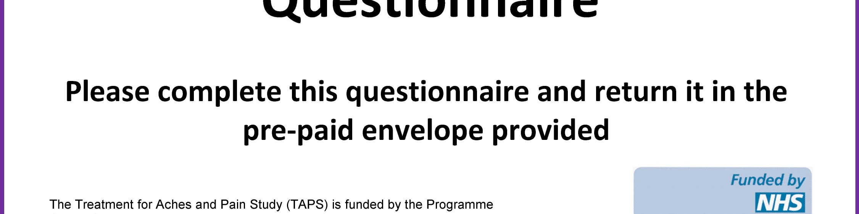
TeleForm ID
INSTRUCTIONS FOR THIS QUESTIONNAIRE
Please complete this form in BLACK pen and BLOCK CAPITALS
The aim of this questionnaire is to find out more about you and your pain.
There are no right or wrong answers and no one will be able to identify you from your responses.
Please answer all the questions unless the instructions ask you to do something else.
Most of the questions can be answered by putting a cross in a box next to or under your answer.
For example: how to answer a question if you don’t have any pain:
No Worst pain pain ever
0 1 2 3 4 5 6 7 8 9 10

If you have any questions, or need help completing this questionnaire, please telephone the TAPS Study Coordinator during office hours on 01782 732950 or email NSTCCG.TAPS@nhs.net.
Thank you for your help with this research study.
Please continue and fill in this questionnaire.
SECTION A ­ ABOUT YOUR PAIN
 |  | / |  |  | / | 2 | 0
D D M M Y Y Please enter TODAY'S DATE
The following questions are about the pain you recently visited your doctor about at your GP Practice.
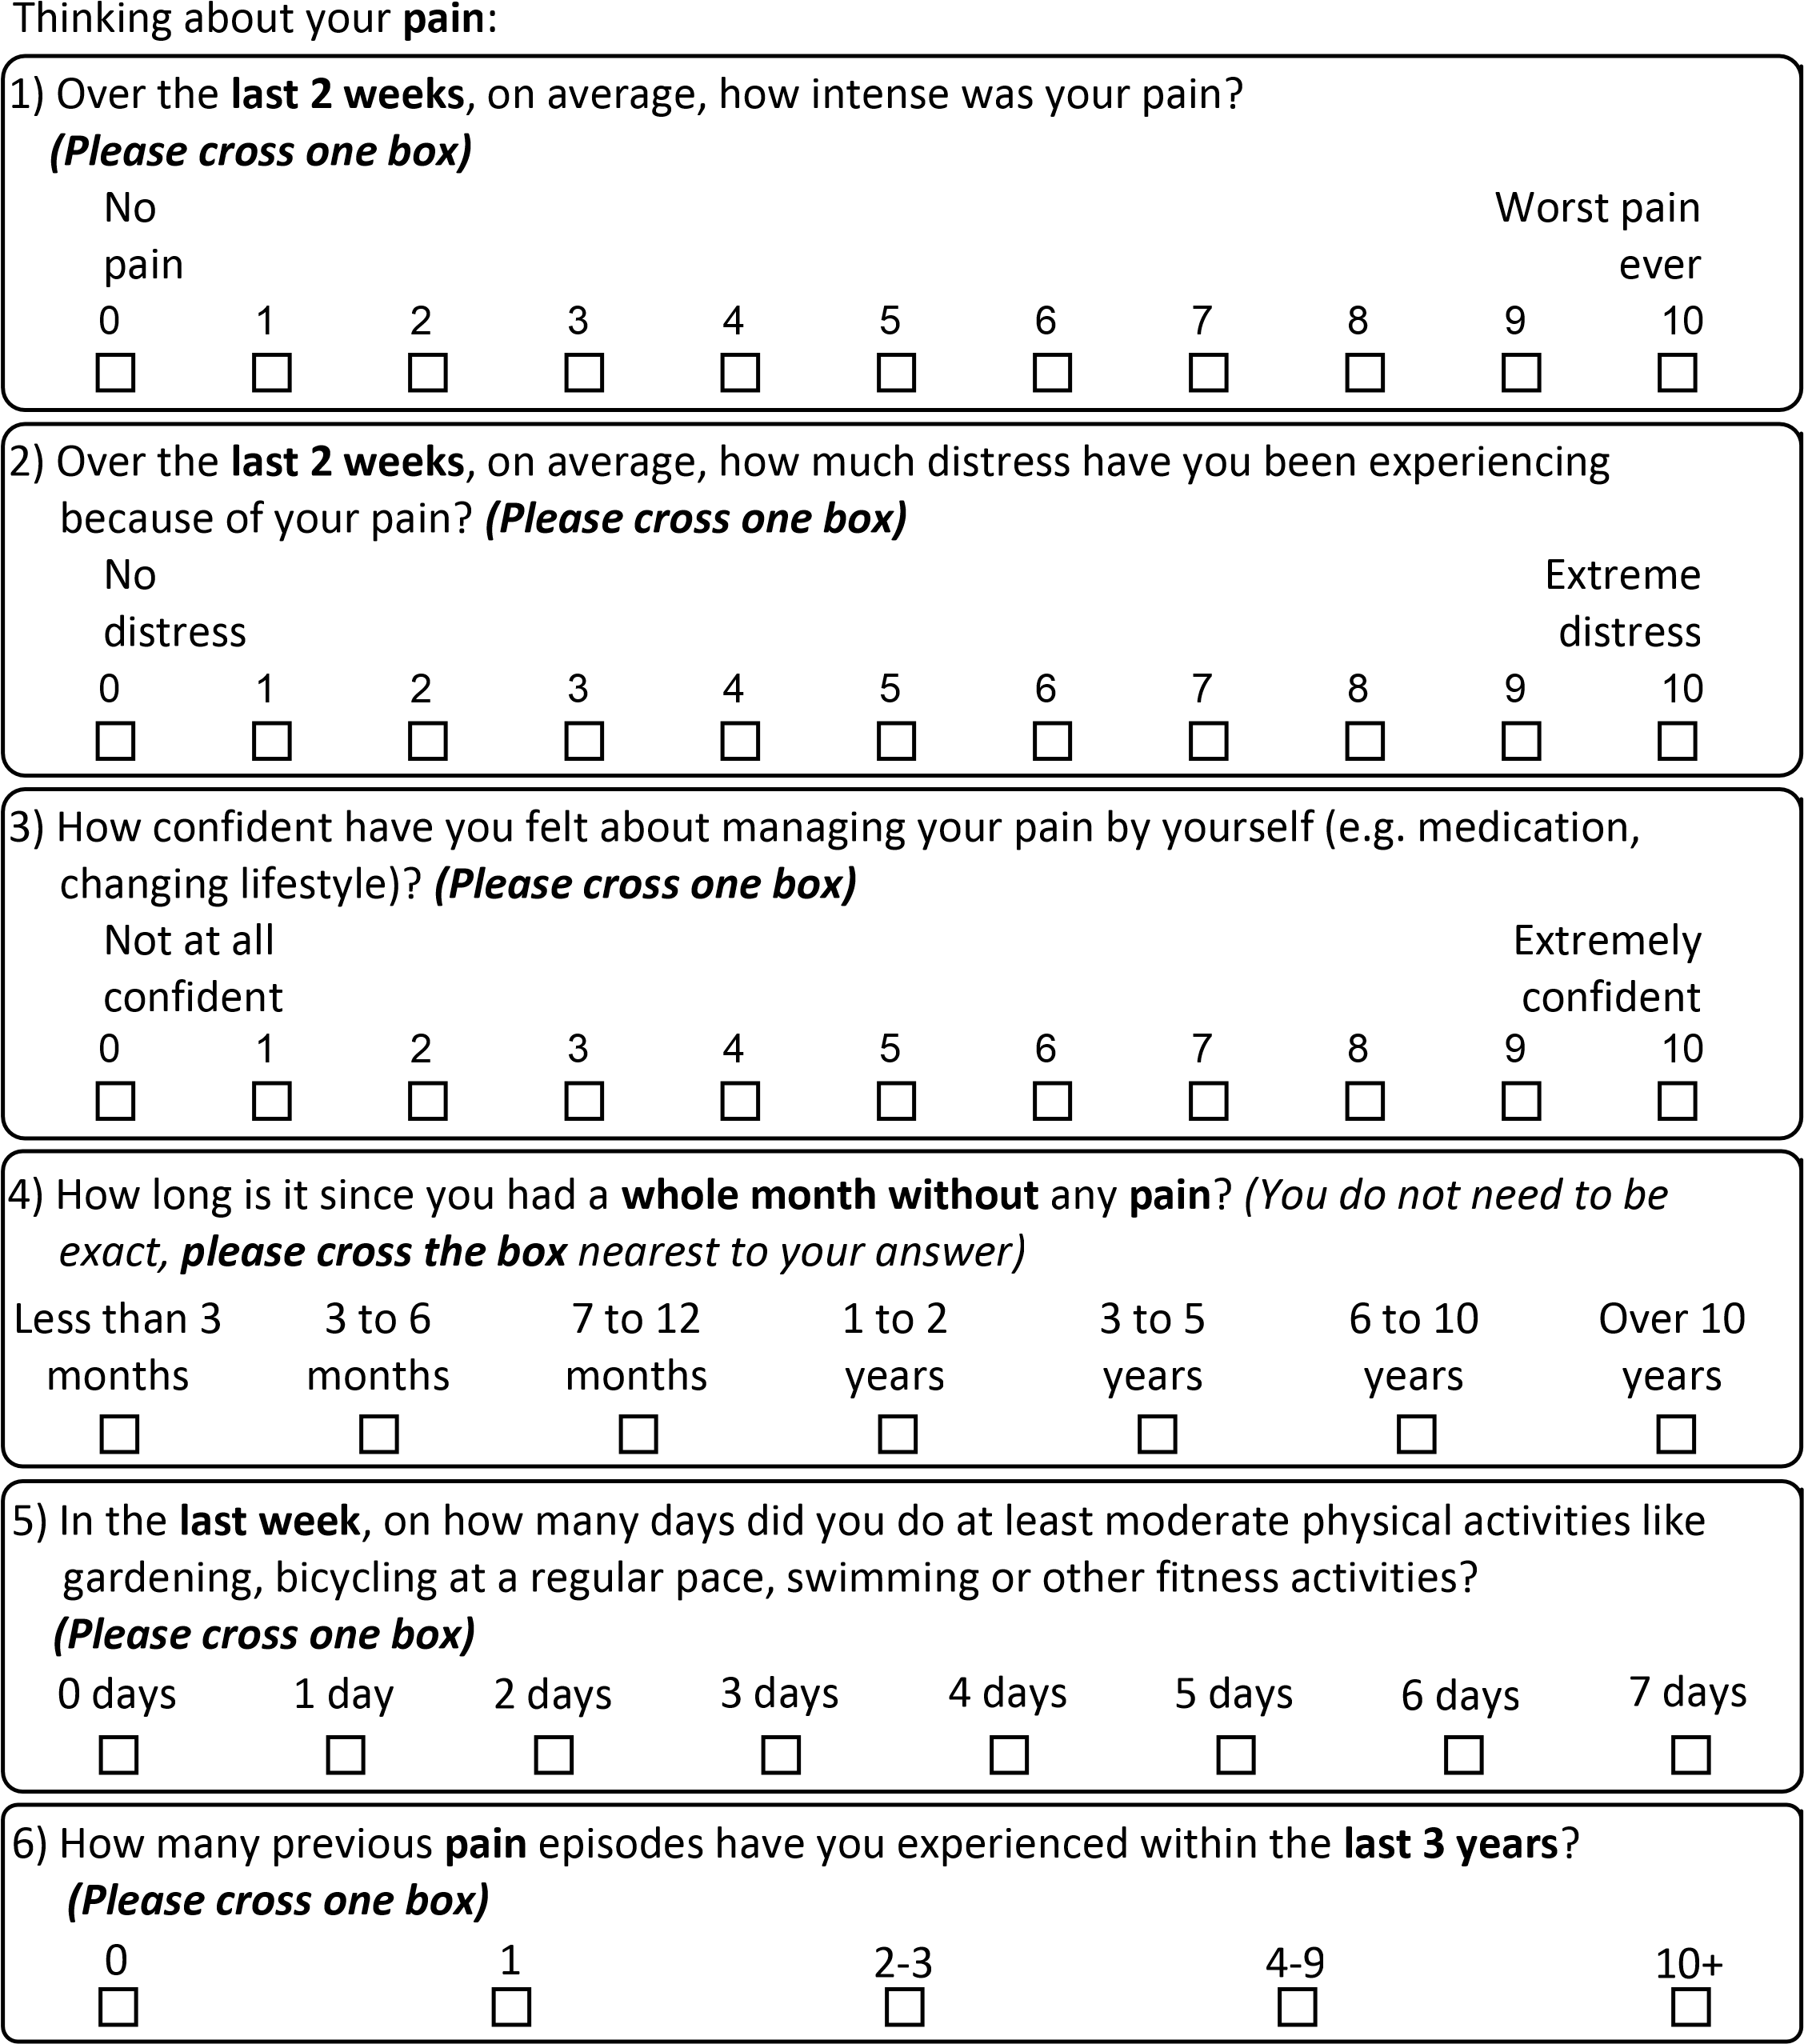

7) These questions ask for your views about your health. This information will help keep track of how you feel and how well you are able to do your usual activities.
For each of the following questions, please cross the one box that best describes your answer.
a) In general, would you say your health is:
Excellent
Very good
Good
Fair
Poor
 | All of the time | Most of the time | Some of the time | A little of the time | None of the time
Accomplished less than you would like
Did work or other activities less carefully than usual
The following questions are about activities you might do during a typical day. Does your health now limit you in these activities? If so, how much?
 | Yes, limited a lot | Yes, limited a little | No, not limited at all
Moderate activities, such as moving a table, pushing a vacuum cleaner, bowling, or playing golf
Climbing several flights of stairs
During the past week, how much of the time have you had any of the following problems with your work or other regular daily activities as a result of your physical health?
 | All of the time | Most of the time | Some of the time | A little of the time | None of the time
Accomplished less than you would like
Were limited in the kind of work or other activities
During the past week, how much of the time have you had any of the following problems with your work or other regular daily activities as a result of any emotional problems (such as feeling depressed or anxious)?
During the past week, how much did pain interfere with your normal work (including both work outside the home and housework)?
Not at all A little bit Moderately Quite a bit Extremely
These questions are about how you feel and how things have been with you during thepast week. For each question, please give the one answer that comes closest to the way
you have been feeling.
How much of the time during the past week...
 | All of the time | Most of the time | Some of the time | A little of the time | None of the time
Have you felt calm and peaceful?
Did you have a lot of energy?
Have you felt downhearted and low?
During the past week, how much of the time has your physical health or emotional problems interfered with your social activities (like visiting with friends, relatives, etc.)?
All of the Most of Some of A little of None of time the time the time the time the time
(SF­12 PCS; Ware, J.E. et al, 2000)
Please continue to think about your pain. For each question cross one box to indicate which statement best describes you over the last 2 weeks.
a) Pain/stiffness during the day How severe was your usual joint or muscle pain and/or stiffness overall during the day in the last 2 weeks? | Not at all | Slightly | Moderately | Fairly severe | Very severe
b) Pain/stiffness at night  How severe was your usual joint or muscle pain and/or stiffness overall during the night in the last 2 weeks? | Not at all | Slightly | Moderately | Fairly severe | Very severe
c) Walking  How much have your symptoms  interfered with your ability to walk in the last 2 weeks? | Not at all | Slightly | Moderately | Severely | Unable to walk
d) Washing/Dressing  How much have your symptoms  interfered with your ability to wash or dress yourself in the last 2 weeks? | Not at all | Slightly | Moderately | Severely | Unable to wash or dress myself
e) Physical activity levels  How much has it been a problem for you to do physical activities (e.g. going for a walk or jogging) to the level you want because of your joint or muscle symptoms in the last 2 weeks? | Not at all | Slightly | Moderately | Very much | Unable to do physical activities
f) Work/daily routine How much have your joint or muscle symptoms interfered with your work or daily routine in the last 2 weeks (including work & jobs around the house)? | Not at all | Slightly | Moderately | Severely | Extremely
g) Social activities and hobbies How much have your joint or muscle symptoms interfered with your social activities and hobbies in the last 2 weeks? | Not at all | Slightly | Moderately | Severely | Extremely

h) Needing help  How often have you needed help from others (including family, friends or carers) because of your joint or muscle symptoms in the last 2 weeks? | Not at all | Rarely | Sometimes | Frequently | All the time
i) Sleep  How often have you had trouble with either falling asleep or staying asleep because of your joint or muscle symptoms in the last 2 weeks? | Not at all | Rarely | Sometimes | Frequently | Every night
j) Fatigue or low energy  How much fatigue or low energy have you felt in the last 2 weeks? | Not at all | Slight | Moderate | Severe | Extreme
k) Emotional well­being  How much have you felt anxious or low in your mood because of your joint or muscle symptoms in the last 2 weeks? | Not at all | Slightly | Moderately | Severely | Extremely
l) Understanding of condition and any current treatment  Thinking about your joint or muscle symptoms, how well do you feel you understand your condition and any current treatment (including your diagnosis and medication)? | Completely | Very Well | Moderately | Slightly | Not at all
m) Confidence in being able to manage your symptoms  How confident have you felt in being able to manage your joint or muscle symptoms by yourself in the last 2 weeks (e.g. medication, changing lifestyle)? | Extremely | Very | Moderately | Slightly | Not at all
n) Overall impact  How much have your joint or muscle symptoms bothered you overall in the last 2 weeks ? | Not at all | Slightly | Moderately | Very much | Extremely  (MSK­HQ;  Hill, J.K. et al. 2016)
For questions a­j, think about just the last 2 weeks (Please cross one box on each row).
a) Pain intensity
On average, how intense was your pain? (0 is 'no pain', 10 is 'pain as bad as it could be').
0 1 2 3 4 5 6 7 8 9 10

Yes No
b) Pain self­management
Have you felt completely unable to manage or control this pain by yourself?
(e.g. using medication or exercises etc.)
c) Pain impact
Over the last 2 weeks, have you been extremely bothered by your pain?
d) Walking short distances only
Have you only been able to walk short distances because of your pain?
e) Pain elsewhere
Are you having troublesome pain in more than one part of your body?
f) Long­term expectations
Are you concerned you're developing a long­term problem?
g) Other important health problems
Are you also having to deal with other important health problems at present?
h) Emotional well­being
Have you felt really anxious or low in your mood because of your pain?
i) Fear of harm
Are you very worried that physical activity might harm you?
j) Pain duration
Have you had your current pain problem for 6 months or more?
(The Keele STarT MSK Tool: Clinical Version)
Have you had any previous surgery for this problem? (Please cross one box).
No related surgery...............................................................................................................
related surgery.................................................................................................................
related surgeries...............................................................................................................
or more related surgeries.................................................................................................
SECTION B - ABOUT YOUR CARE
1) The following questions concern your doctor's communication and behaviour during your consultation. Please answer all the questions as honestly as you can remember regarding whether or not each statement applies to something your doctor said or did (please cross one box on each row).
Not at A great
To what extend did your doctor... _{all} deal
Tell you that everything would be fine...............................................
Show that he/she understood your concerns....................................
Reassure you that he/she had no serious concerns about your pain
Explain how the treatment offered would help with your problem
Tell you that you should not be worried.............................................
Listen attentively while you were talking............................................
Make sure you understood what your treatment plan involves........
Put you at ease....................................................................................
Summarise what you had told them....................................................
Show a genuine interest in your problem............................................
k)Encourage you to voice your concerns regarding your symptoms
l) Check you understood the explanation he/she gave for your ...........
symptoms (Holt et al. 2016)
Did you receive any printed or online information from your doctor about your pain?
(Please cross one box)
Yes No Don't Remember
How satisfied are you with the care you have received for your pain in the last few months? (Please cross one box)
Very satisfied Quite satisfied No opinion Not very satisfied Not at all satisfied
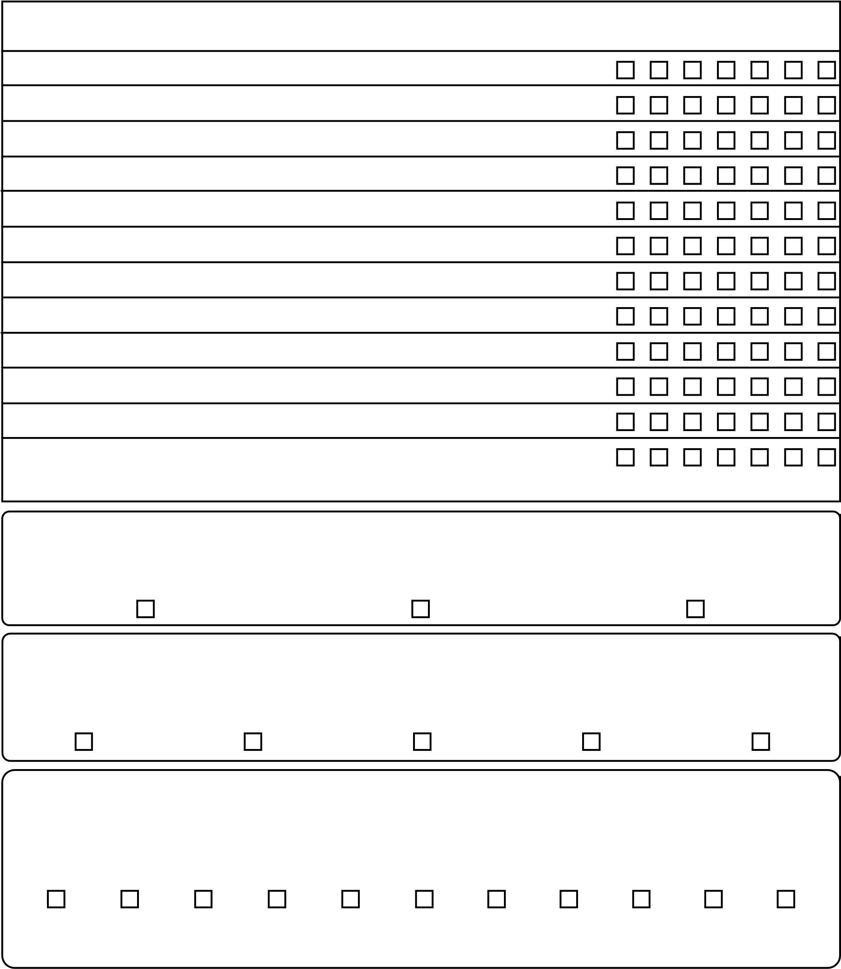
With respect to your pain, how would you describe yourself now compared to how it was when you recently saw your doctor?
Put a cross in the box that best describes your pain now:
­5 ­4 ­3 ­2 ­1 0 1 2 3 4 5
Very much Unchanged Completely worse recovered

SECTION C - ABOUT YOUR GENERAL HEALTH
Under each heading, please cross the ONE box that best describes your health TODAY.
UK (English) © 2009 EuroQol Group EQ­5D™ is a trade mark of the EuroQol Group
ANXIETY/DEPRESSION
I am not anxious or depressed
I am slightly anxious or depressed
I am moderately anxious or depressed
I am severely anxious or depressed
I am extremely anxious or depressed
PAIN/DISCOMFORT
I have no pain or discomfort
I have slight pain or discomfort
I have moderate pain or discomfort
I have severe pain or discomfort
I have extreme pain or discomfort
USUAL ACTIVITIES (e.g. work, study, housework, family or leisure activities)
I have no problems doing my usual activities
I have slight problems doing my usual activities
I have moderate problems doing my usual activities
I have severe problems doing my usual activities
I am unable to do my usual activities
SELF-CARE
I have no problems washing or dressing myself
I have slight problems washing or dressing myself
I have moderate problems washing or dressing myself
I have severe problems washing or dressing myself
I am unable to wash or dress myself
MOBILITY
I have no problems in walking about
I have slight problems in walking about
I have moderate problems in walking about
I have severe problems in walking about
I am unable to walk about
This is a list of phrases which other patients have used to express how they view their condition. Please put a cross in the box that best describes how you feel about each statement (please cross one box on each row).
 | Strongly Disagree | Somewhat Disagree | Somewhat Strongly Agree Agree
a) I'm afraid I might injure myself if I exercise
b) If I were to try to overcome it, my pain would increase
c) My body is telling me I have something dangerously wrong
d) People aren't taking my medical condition seriously enough
e) My accident/problem has put my body at
risk for the rest of my life
f) Pain always means I have injured my body
g) Simply being careful that I do not make any unnecessary movements is the safest thing I can do to prevent my pain from worsening
h) I wouldn't have this much pain if there wasn't something potentially dangerous going on in my body
i) Pain lets me know when to stop exercising so that I don't injure myself
j) I can't do all the things normal people do because it's too easy for me to get injured
k) No one should have to exercise when he/she is in pain |  |  | (adapted from TSK­11; Woby et al. 2005)
What long term medical conditions do you have? (Please cross all boxes that apply)
Diabetes..............................................................................................................................
Breathing problems / Chronic Obstructive Pulmonary Disease (COPD) / Asthma...........
Heart problems or high blood pressure.............................................................................
Chronic fatigue syndrome, ME, fibromyalgia or widespread pain....................................
Anxiety, depression, stress.................................................................................................f) Other (please state):
SECTION D - ABOUT YOU & RECENT EMPLOYMENT HISTORY
Do you currently live alone?
2)
)
Please cross one box
(
Yes
No
1)
What is your ethnicity?
(
Please cross one box
)
Mixed
Asian
Black
White
Other
Prefer not to say
3)
What is your current or most recent paid
job title
(
even if you are now retired)?
4)
What type of work is (or was) this job (e.g. banking, building, cleaning, pottery, office, retail,
etc.)?
5)
Are you currently in paid employment (full­time or part­time)?
(
Please cross one box
)
Yes
No
Please go to
Question 6
.
If not in paid employment please go to
Question 8 on the next page
.
6)
On average to what extent has your
pain
or related problem affected your performance at
work over the past
6
months
?
)
Please cross one box
(
0
1
2
3
4
5
6
7
8
9
10
Not at all
So bad I am unable
to do my job

Days
Weeks
Months
7)
Have you taken time off work in the last
6
months because of your pain
?
Please cross one box
)
(
Yes
No
Please see below.
Please go to
Question 8
.
If yes, please write the number of days, weeks or months you were off work due to your
pain
in the last
6
months
.
For these questions think about just the last two weeks.
Please cross one box for each question below | Yes | No
a) Do you often feel unsure about how to manage your pain condition?
b) Have you had troublesome joint or muscle pain in more than one part of your body?
c) Do you think your condition will last a long time?
d) Do you have other important health problems?
e) Has pain made you feel down or depressed in the last two weeks?
f) Do you feel it is unsafe for a person with a condition like yours to be physically
active? (The Keele STarT MSK Tool: Self­report Version)
How often do you need to have someone help you when you read instructions, pamphlets, or other written material from your doctor or pharmacy? (Please cross one box)
Never Rarely Sometimes Often Always
(Morris et al. 2006)
Please confirm that you are the patient completing this yourself or if someone else is completing it on your behalf? (Please cross one box)
I am the patient I am a carer/relative I am staff I am someone else
Please continue onto the next page...
For Office Use Only:
Logged 1 | DB Logged | Data Entry | Quality Checked

Study ID
Please ensure that you have read the enclosed patient information leaflet that explains the TAPS study and that you provide all the information required below if you are willing to take part.
You will receive 3 short questions each month for 6 months to find out how your
pain levels change. We would prefer to send these questions to you by text message
but if you are unable to receive text messages then you can receive these questions
by post instead.
Please
cross one box
to indicate how you would like to receive your 3 questions
each month:
Text
(
please ensure that you provide a mobile number below
)
Post
We need the following personal information to contact you:
SECTION E - CONSENT
Title:
__________
Forename:
_________________
Surname:
___________________
Address:
_____________________________________________________________
____________________________________________________________________
____________________________________________
Post Code:
_______________
Home Telephone Number:
Mobile Telephone Number:
Prefer Not to Say
Female
Male
Gender:
Date of Birth:
D D M M Y Y Y Y
/
/
Please now sign the CONSENT FORM on the next page

It is important that you understand that by signing the consent form below you are agreeing to ALL of the following:
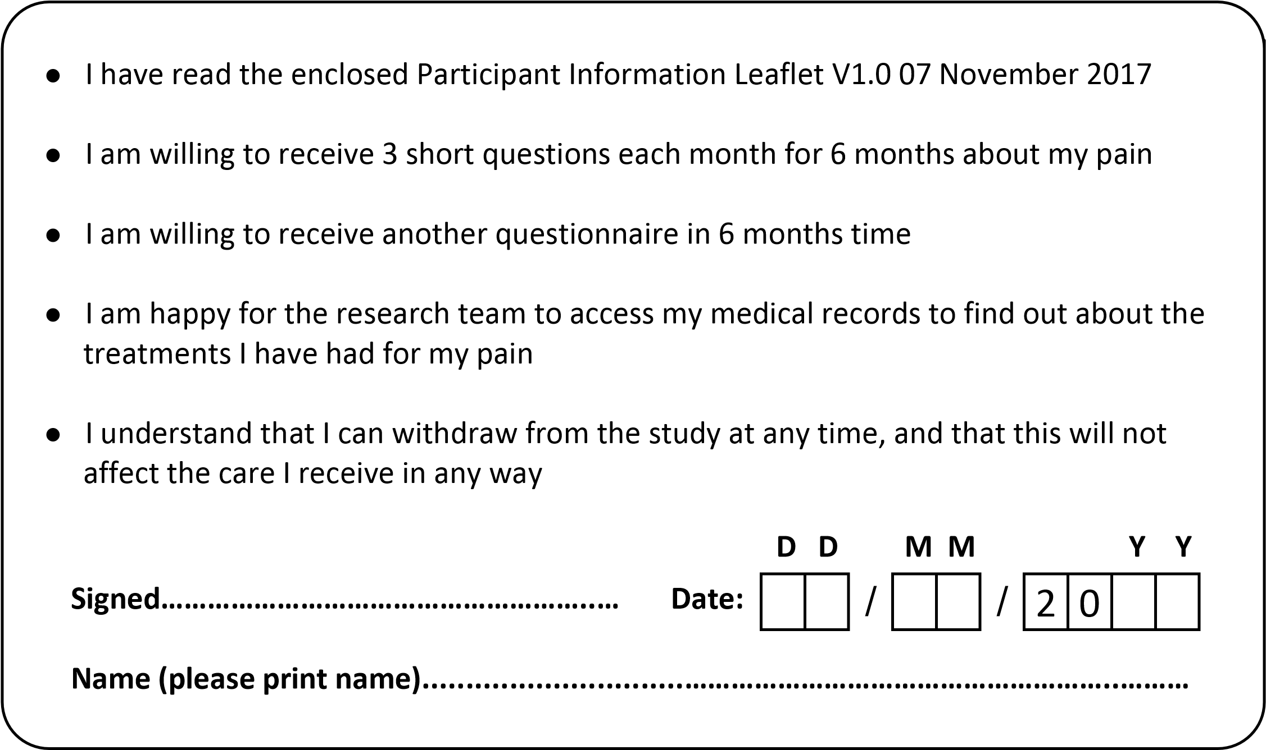
I am willing to be contacted about further research in relation to the TAPS study
(
OPTIONAL
)
I would like a summary of the study results to be posted out to me once they are
published
(
OPTIONAL
)
Please now return your signed questionnaire in the pre­paid envelope provided (you do not need a stamp).
If you have any questions about the study or need further information please contact the TAPS Study Coordinator during office hours on 01782 732950 or email NSTCCG.Taps@nhs.net.
For Office Use Only:
Logged 1 | DB Logged

Study ID

