Panel discussion: 'Decolonising Education' – Why is My Curriculum White?
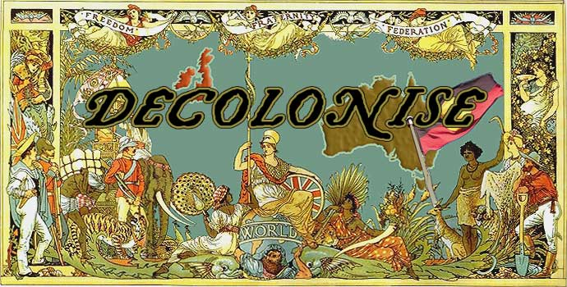
Wednesday 28 February 2018
Keele University Student Union (KUSU), downstairs area opposite Munch
On 28 February 2018 UCU will be holding a day of action against workplace racism, and all ucu branches are organising events with the headline of ‘Decolonising Education’. The below is what we’ve planned for Keele:
PROGRAMME
3.15 Tea/ coffee
3.30 – 3.50 Shalini Sharma and Rachel Bright (History), ‘Decolonising the History Curriculum’
3.50 – 4.00 Linda Ahall (SPIRE), ‘How to improve diversity in our curriculum: A lesson from Sweden’
4.00 – 4.10 Rajmil Fischman (Music), ‘Cultural colonialism in Music’
4.10 – 4.30 Harjinder Kaur and Karen Adams (Nursing and Midwifery), 'Decolonising Nursing and Midwifery Curriculum?'
Tea/ coffee break
4.45 – 5.30 Questions/ Discussion
___________________________________________________________________________
www.ucu.org.uk/equality

