My social story: What I will do to get help for an urgent or emergency health problem at home at night or at the weekend

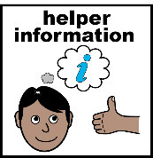
Facilitator notes
- Use this example as a starting point.
- Encourage individuals to think about what they might want to include in their story.
- Review and download/edit/print in advance of a session.
- Click here for more information about writing a social story.
- Click here to visit easy on the i for more pictures.

Creating your social story
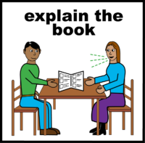 | You can use this story for yourself.
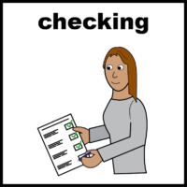 | You will need to check and see if you want to change anything or add your own pictures.
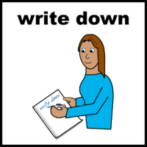 | There are some spaces for you to write in your own information if you want to.
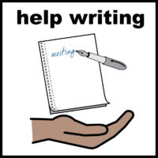 | You can ask someone to help you do this.

My social story
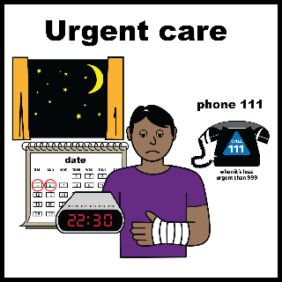 |  | or | 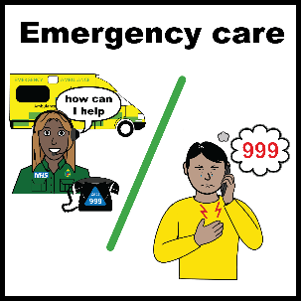
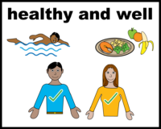 | I am usually healthy and feel well.
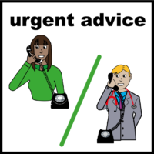 | If I get ill or have an accident, I know what to do to get the right help.

Getting help or advice
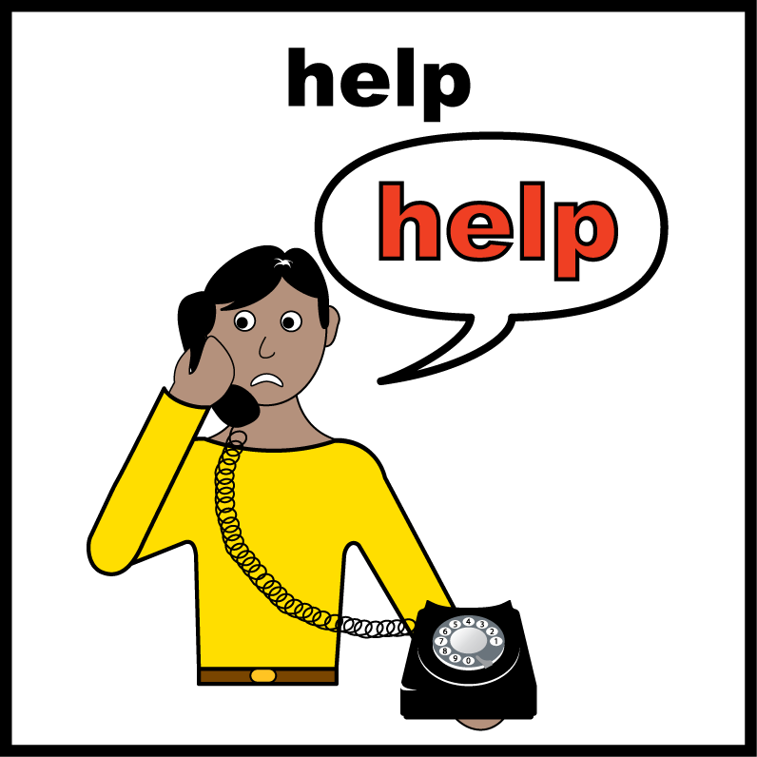
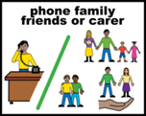 | If I need help or advice, I will call my family, friend, or support worker.
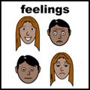 | I will tell them how I am feeling.
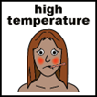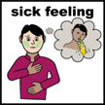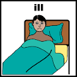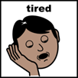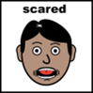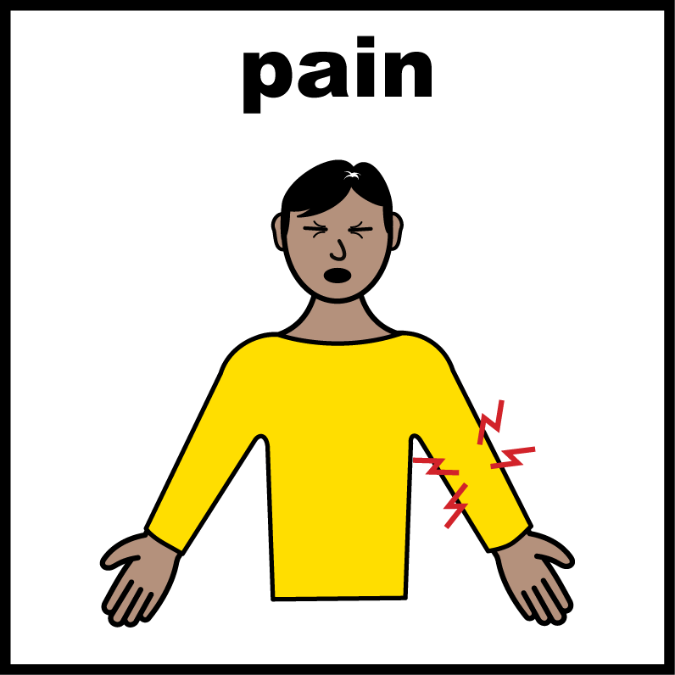

 |  | 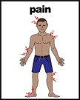 |  | I will tell them if I am in pain.
 |  |  |  | My pain is in my
 |  |  |  | I will tell them how bad my pain is.
 | 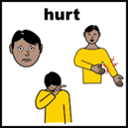 |  |  | If I have hurt myself, I will tell them what happened.
 | 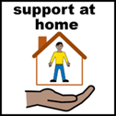 |  |  | They might come to support me.
 | 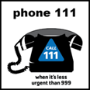  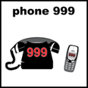 |  |  | They might call 111 or 999 for me, or they might advise me who to call.
 | 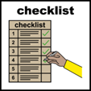  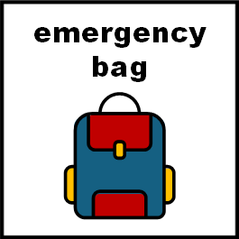 |  |  | I will get my ‘information about me’ list from my emergency bag; it has all my key details so I will be able to answer questions.
 | 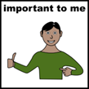 |  | I will need
 | 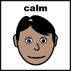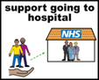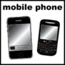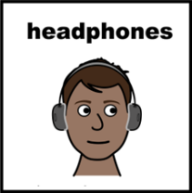
I will pack the things on my list that are not already in my emergency bag, so it’s ready to take with me if I need to go to hospital.
My family, friend, or support worker might do this for me.

When I am on my own
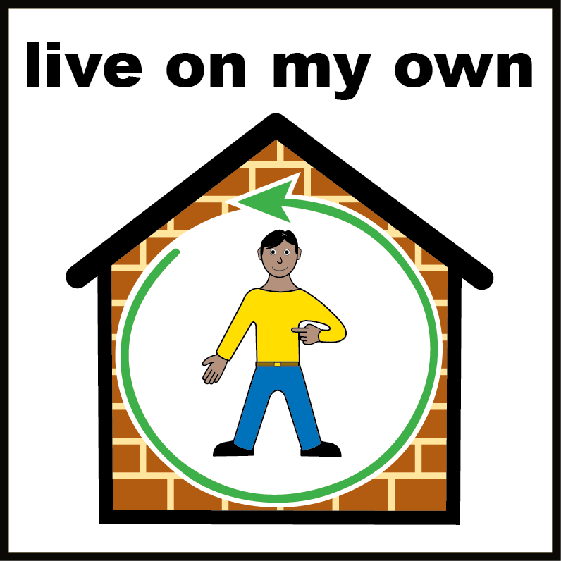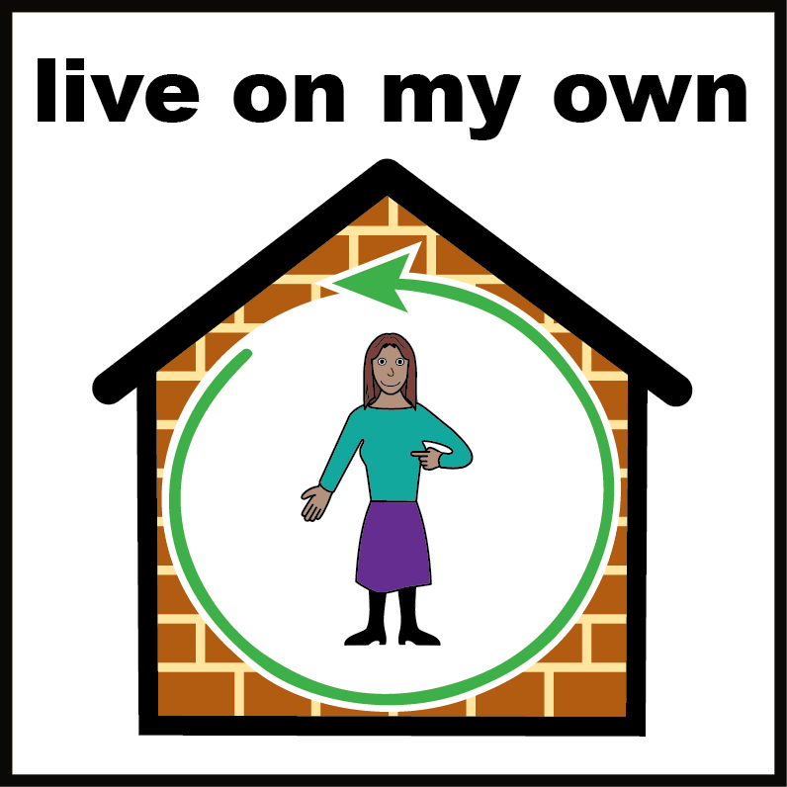
If I am alone, I will look at the information about urgent and emergency care to decide if I need to call 111 or 999.
I will think about how I am feeling.
If I have hurt myself, I will think about what happened, so I will be able to tell someone else.
I will think about if I am in pain and where I am in pain.
My pain is in my

I will think about how bad my pain is.
If I decide I need help quickly, I will call 111.
Or if I think it’s a serious emergency I will call 999.

Calling 111
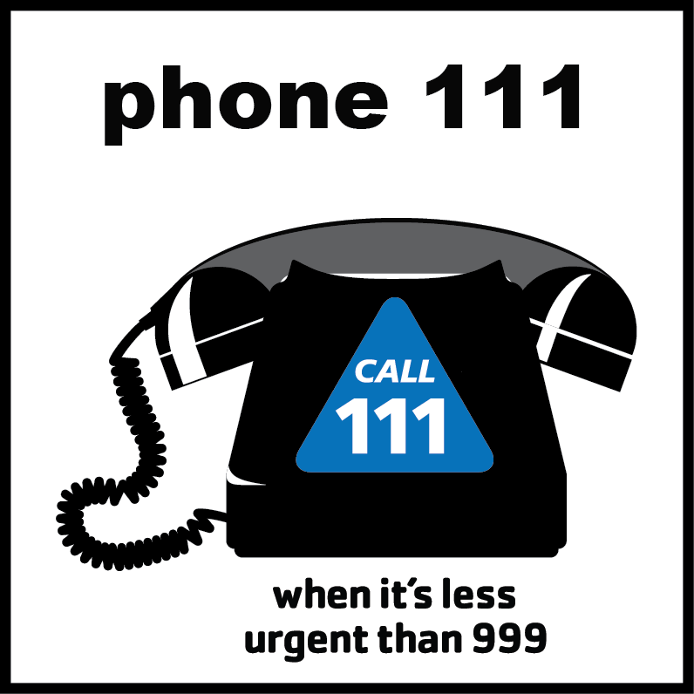
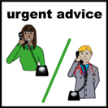 |  | If I call 111 the call taker will ask me questions about what is wrong, and how I am feeling.
I will use my ‘information about me’ list from my emergency bag to help me answer the questions.
I will tell the call taker how I’m feeling and if I’m in pain.
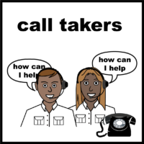 |  | I will tell the call taker any things I don’t like, or that scare me.
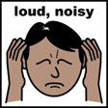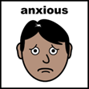
 | If I have hurt myself, I will tell the call taker what happened.
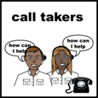 | The call taker will tell me what to do. The call taker can do things to help me.
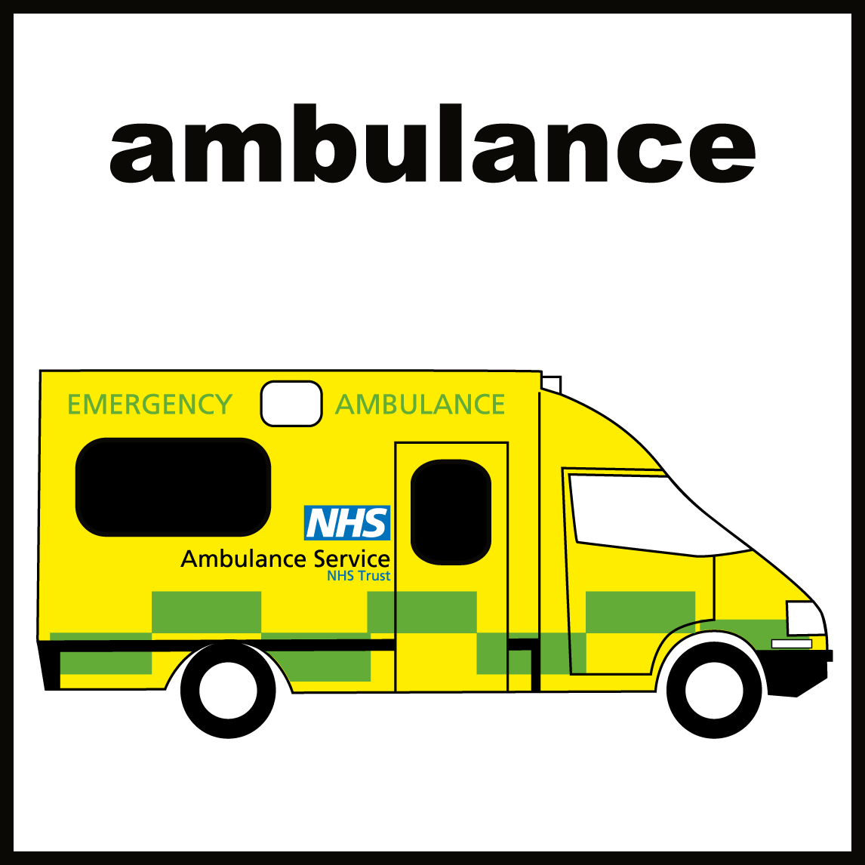 | They can call an ambulance for me if they think it’s an emergency and I should get to hospital as quickly as possible.
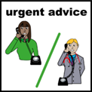  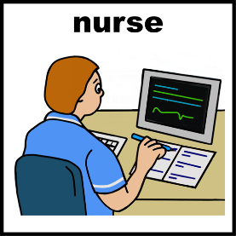 | They can arrange for a nurse to call me back to check how I’m feeling and tell me what to do.
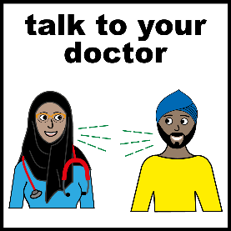  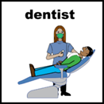 | They can make an appointment for me to see a doctor or dentist if I need one.
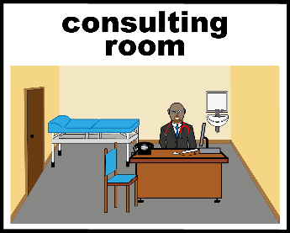  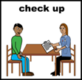 | If it’s not an emergency, but they think I need urgent help like medication or tests, they will tell me to go to hospital or the urgent care centre to see a doctor or nurse there.
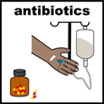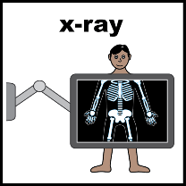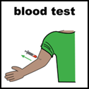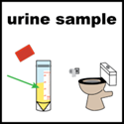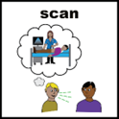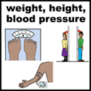

Calling 999
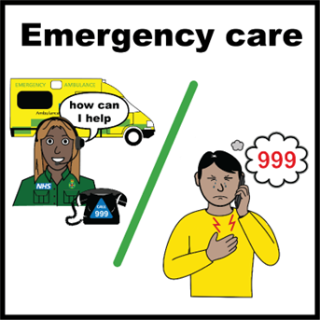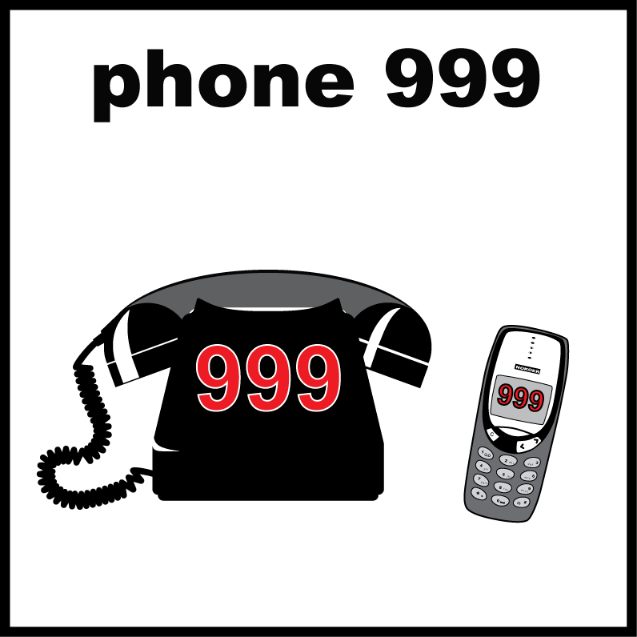
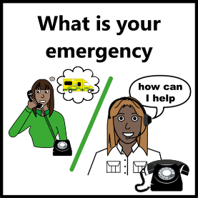 |  | If I call 999 the call taker will ask me questions about what is wrong.
I will use my ‘information about me’ list from my emergency bag to help me answer the questions.
I will tell the call taker how I’m feeling and if I’m in pain.
 |  | I will tell the call taker any things I don’t like, or that scare me.
 | If I have hurt myself, I will tell the call taker what happened.
 | The call taker will tell me what to do.
 | They will send an emergency ambulance to me.
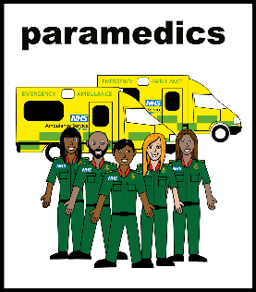 | When the ambulance arrives, the paramedics will check to see if I need to get to hospital quickly.
I will tell them where to find my emergency bag.
My family, friend, or support worker might tell them about my emergency bag.
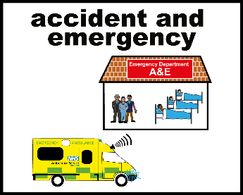 | If we agree I need to go to hospital straight away, the ambulance will take me to Accident & Emergency.
 | I will take my emergency bag with me. My family, friend, or support worker might bring this for me.
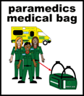 | If the paramedics help me feel better, we might decide it would be better to stay at home, and to see my GP or pharmacist tomorrow.

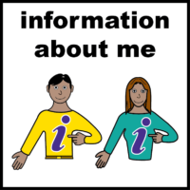
Optional:
This information might already be in your hospital passport or health profile

Information about me, to help me answer questions
☐ My date of birth:
☐ My address:
☐ My phone number:
☐ Names and phone numbers of people who help me:
☐ The name and address of my GP (doctor):
☐ Other important information:

All ‘easy on the i’ images copyright © LYPFT

