Going to Hospital: What to have in your emergency bag

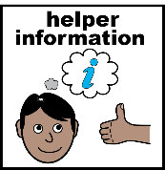
Facilitator notes
- Use this guide one-to-one or in group sessions.
- Review and download/edit/print in advance of a session.
- Encourage individuals to think about what they might need to include.
- Talk about occasions when the emergency bag might be useful.
- Talk about where the bag could be kept.

Emergency bag
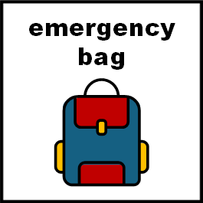 | It’s a good idea to keep an emergency bag ready in case you need to go to hospital quickly.
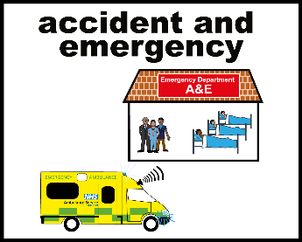 | In your bag, you can pack things that help you when you go to hospital.
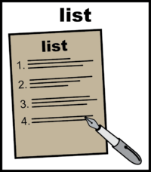 | It will help if you also have an emergency list of things that you want to take that are not already in the bag. For example, you might have some special food or drink, that you will need to pack on the day.
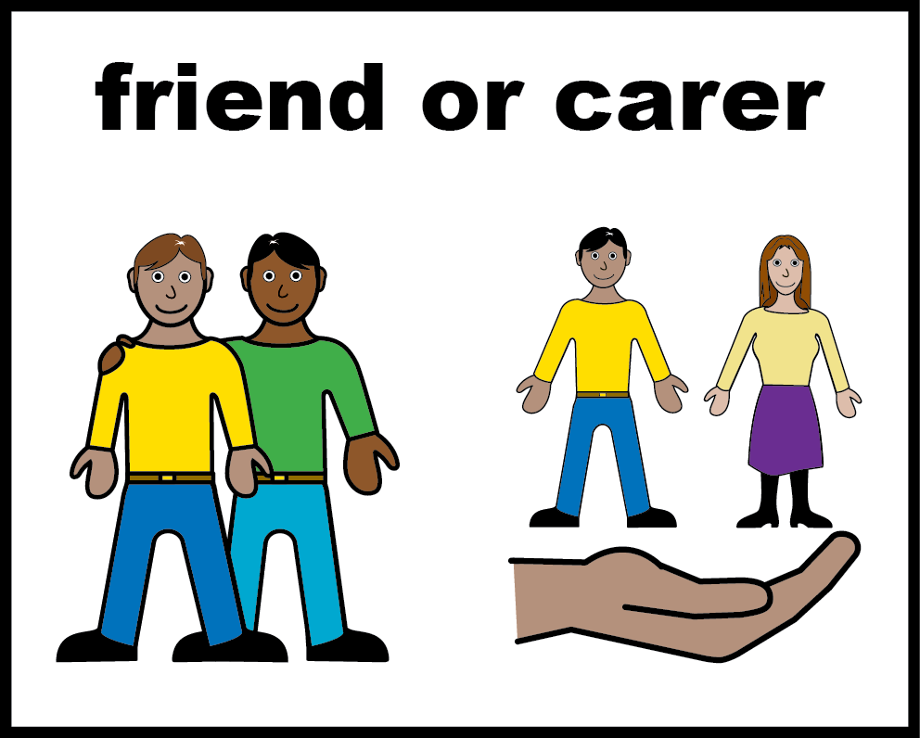 | If you are going to hospital with a carer, you could also pack things they will need.
On the next few pages is a list to help you pack the right things.
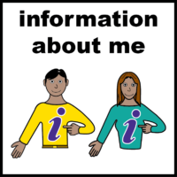

Important information
☐ My hospital passport or health profile (this tells staff how to help me).
☐ My date of birth, address and phone number.
☐ Names and phone numbers of people who help me.
☐ The name and address of my GP (doctor).
☐ A list of my medicines.
☐ A list of my diagnosis or health needs.
☐ My care plan or health action plan (if I have one).

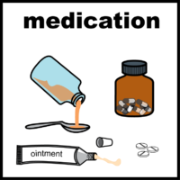

Medicines
☐ All the medicines I take including creams (in the box or bottle).
☐ Any things I need to stay well (like asthma inhaler or glasses or a hearing aid).
☐ A bottle of water.
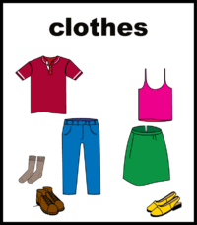

Clothes
☐ A jumper or hoodie and pair of socks in case it gets cold.
☐ A change of clothes; something comfortable and loose-fitting.
☐ Pyjamas, dressing gown and slippers.
☐ Underwear and socks in case you are there for a long time.
☐ A plastic bag to put dirty things in.

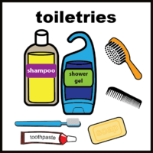

Wash things
☐ Toothbrush and toothpaste.
☐ Continence or menstruation products if needed.
☐ Hygiene wipes.
☐ Towel.
☐ Tissues.

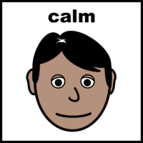

Things that help me wait or to feel calm
☐ A book or activity.
☐ My favourite toy or blanket.
☐ Headphones or earplugs if I don’t like noise.
☐ Sensory toys or something to hold.
☐ Tablet or phone with a charger.

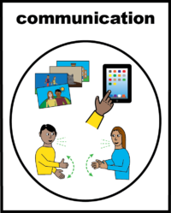

Help with communication
☐ My communication book or communication aids if needed.
☐ A note to tell staff about how I need them to communicate with me.
☐ A phone with charger.
☐ A notepad and pen to ask the doctors and nurses to write down what they tell you.

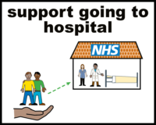

Support
☐ Someone who helps me and can come with me (if needed).
☐ Some change for the vending machine, café or taxi.
☐ A drink and a snack.

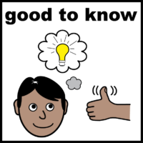
Good to know
Keep this information in your emergency bag.
☒ Mark the box when you put an item in your bag.
Keep your bag in a place that is safe but is easy for you to get to in a health emergency.
Important:
- Get your emergency bag ready when you are well
- Don’t delay calling for help if you need it
- You don’t need an emergency bag to get care
- Preparing an emergency bag is your choice
My list
A list of things I want to take that are not already in the emergency bag because I use them all the time, or because they need to be kept in the fridge, or because they might not work if they are in the bag for a long time.
☐
☐
☐
☐
☐
☐
☐
☐

Information on where to find these things
☐
☐
☐
☐
☐
☐
☐
☐

Optional:
This information might already be in your hospital passport or health profile

Information about me, to help me answer questions
☐ My date of birth:
☐ My address:
☐ My phone number:
☐ Names and phone numbers of people who help me:
☐ The name and address of my GP (doctor):
☐ Other important information:

All ‘easy on the i’ images copyright © LYPFT

