

Connecting your Practice Management System (PMS) to the Data for Impact (DfI) Platform
Overview
What this integration does
This guide explains how to connect your Practice Management System (PMS) to the Data for Impact (DfI) platform using an API key.
Once connected, eligible patient details automatically transfer from your PMS into DfI, removing the need for manual enrolment directly on to the DfI platform. When a patient is added to your PMS, their details flow securely into DfI and patient surveys are sent automatically at the appropriate time.
You can then view:
- Individual patient survey responses (via the DfI platform)
- Aggregated clinic-level outcomes and benchmarking (via the DfI dashboard)
This integration is designed to reduce administrative burden and fit into routine clinical workflows.

One-off setup
You only need to complete this process once. After the API connection is set up, eligible patient details will continue to transfer automatically from your PMS into DfI.

Data protection and GDPR
To reassure you and your patients:
- No clinical notes, treatment records, or free-text data are shared
- Only the minimum information required to enrol patients into DfI and send surveys is transferred (for example: name, contact details, D.O.B and appointment details)
- All data are handled in line with GDPR requirements and the DfI governance framework, hosted at Keele University

Important: eligibility filtering (why this matters)
Practice Management Systems may also include patients who should not be enrolled into DfI, for example:
- Non-physiotherapy appointments in multidisciplinary clinics
- Non-MSK or non-eligible services
For this reason, part of the setup involves adding a simple eligibility filter in your PMS. This ensures that only appropriate patients are sent to DfI, protecting data quality and avoiding inappropriate survey delivery.
As part of this process, we will guide you through:
- How to set up the API link
- Where to add an eligibility filter in your PMS (if applicable i.e. if you have patients who are not eligible for enrolment to the DfI)
- How to label or flag eligible patients
- How to test the connection safely before going live

What happens after setup
Once connected and tested:
- Eligible patients are enrolled automatically onto the DfI platform
- Patient surveys are sent without any additional administrative work
- Your clinic’s data contribute to the national MSK evidence base
- You gain access to meaningful benchmarking and reporting via the DfI dashboard

How to set up the API connection and eligibility filtering
Connecting your PMS to the DfI platform involves two simple steps, regardless of which PMS you use:
- Create an API key
This allows your PMS and the DfI platform to communicate securely.
- Set up eligibility filtering
This controls which patients are sent to DfI, ensuring only appropriate physiotherapy patients are enrolled.
You only need to complete these steps once. Once the connection is live, the system will continue to work automatically in the background.
We have established API integrations with the following Practice Management System (PMS) providers, with plans to expand these integrations further in the future:
- Nookal (page 4)
- Cliniko (page 6)
- TM3 (coming soon)
- PPS (coming soon)
Please see the relevant pages and then information on how to test the API connection (page 9).


To link with Nookal
A. Create your API Key & Secret (Nookal)
- Log in to Nookal using an Owner or Admin account
- Go to Setup
- Select Integrations
- Open API Keys
- Click New API Key
- Name it:
“MSK Data for Impact”
- Nookal will generate:
  - API Key
- Copy both values
- Paste them into the DfI PMS Integration form (see Account page; connect to PMS)
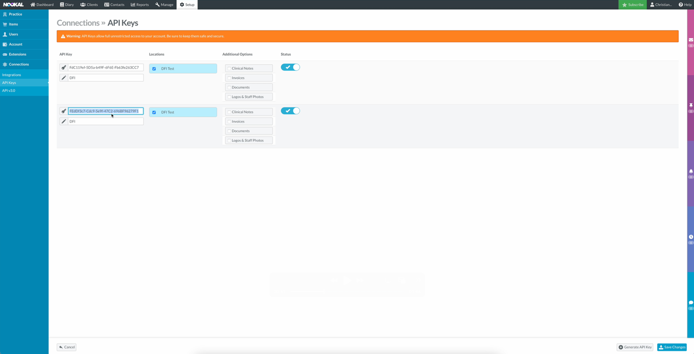
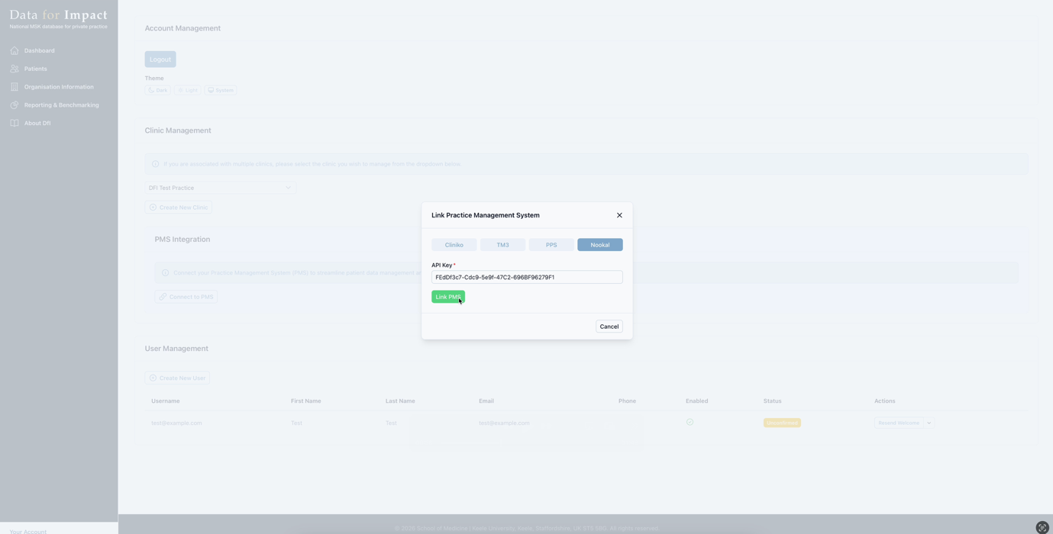

B. Set up eligibility filtering (Nookal)
In order to filter patients that whose details you don’t want to be sent to DFI, follow the steps below.
- Go to Extras on the practice settings.
- Create an extra field with the type as “Checkbox” and the name “Enrol in DFI?”.
- Add one option with the value “Yes”
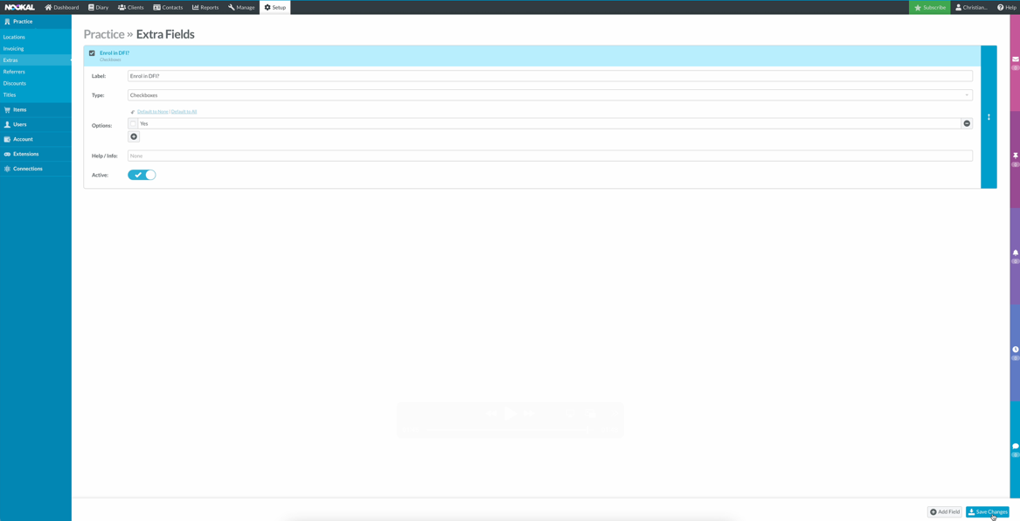
- When a patient is enrolled into your PMS, you will now see a checkbox, which will need to be checked in order for patient and appointment data to be sent to DFI.


To link with Clinko
A. Create your API Key (Cliniko)
- Log in to Cliniko as an Administrator
- Go to Settings
- Select API
- Click Add API Key
- Name it:
“Data for Impact (DfI)”
- Copy the generated API key
- Paste into the DfI PMS Integration form (see Account page; connect to PMS). Once pasted, click “Link PMS” – you will then be asked which Practice you would like to link from your PMS.
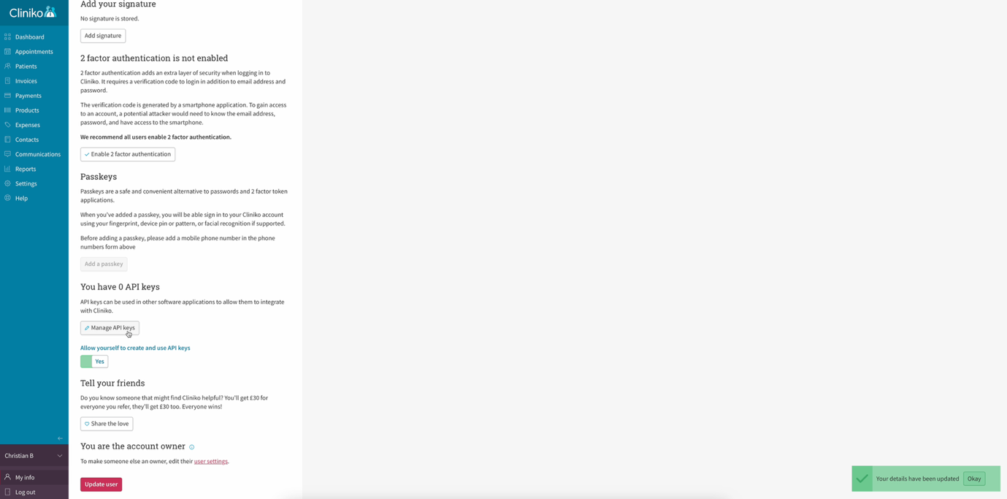
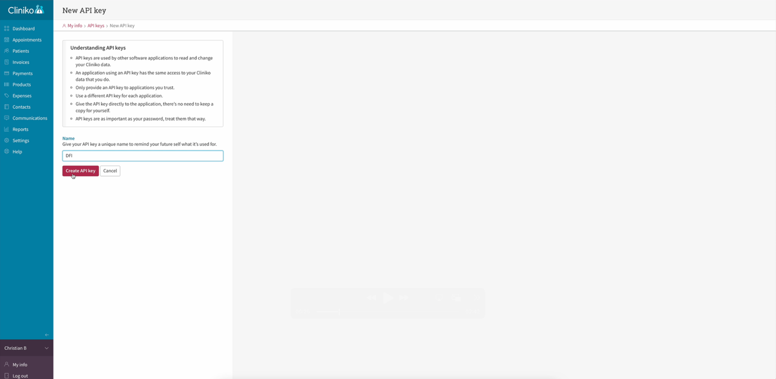
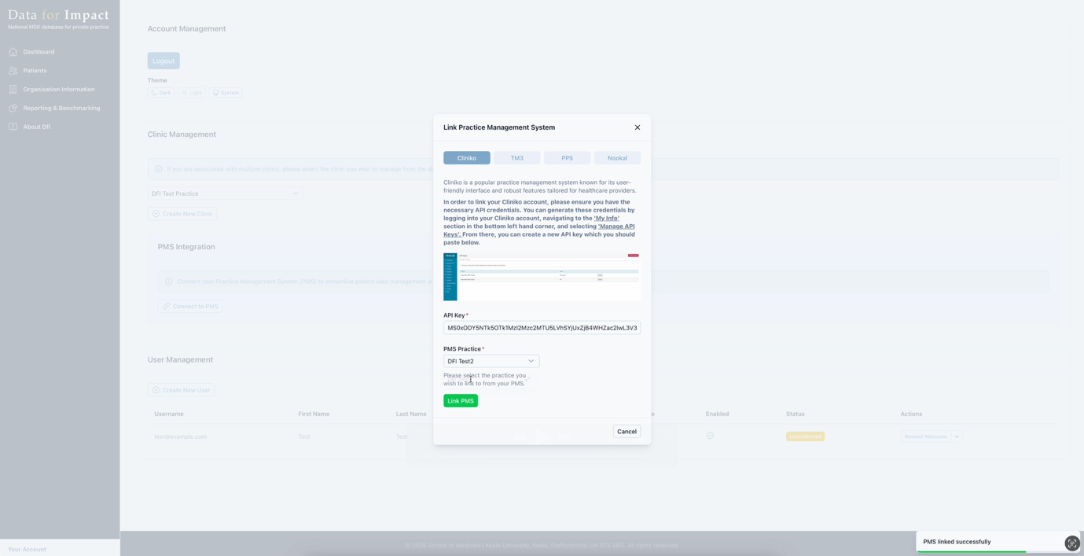
B. Set up eligibility filtering (Cliniko)
In order to filter patients that whose details you don’t want to be sent to DFI, follow the steps below.
- Go to “Settings” and click “Custom Patient Fields”
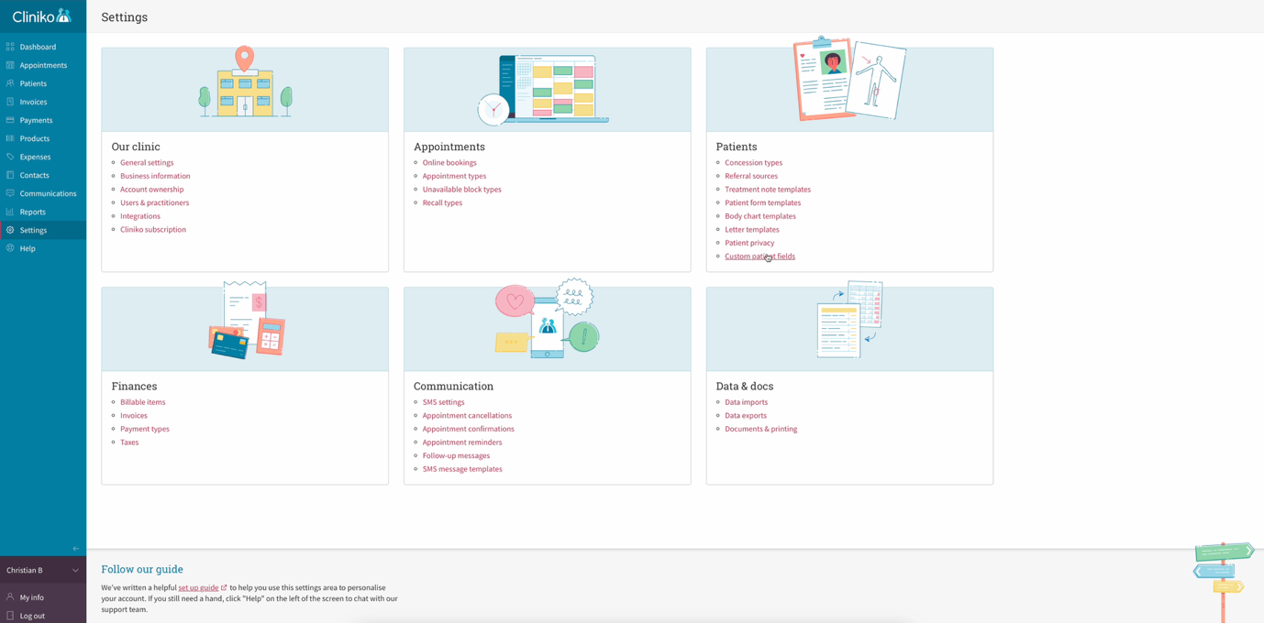

- Create a new section called “DFI” and a new checkbox field called “Enrol in DFI”, with one option labelled “Yes”. Once complete, save the field.
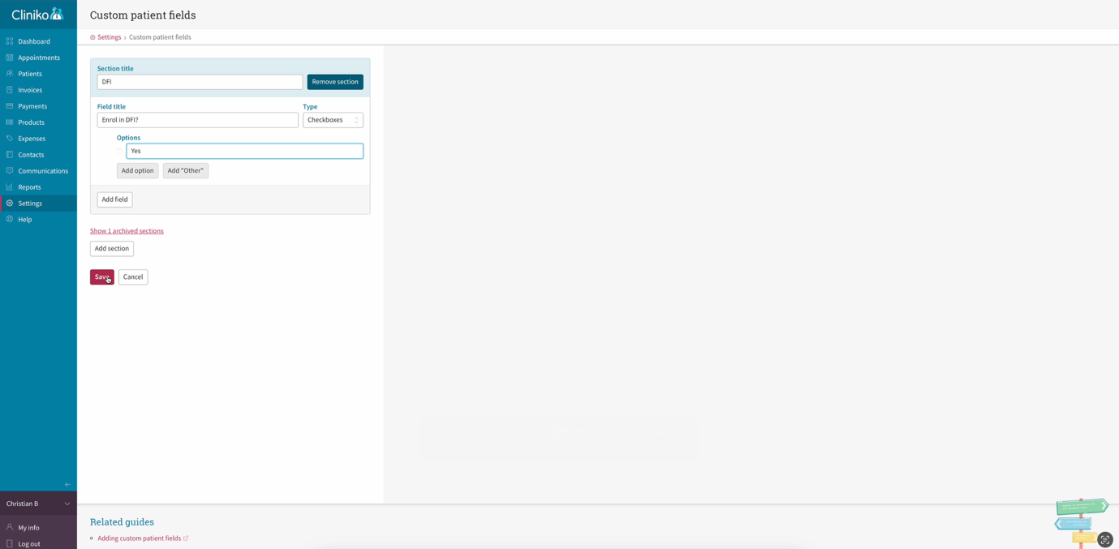

- When enrolling new patients in your PMS, you will now see a checkbox called “Enrol in DFI?”, which needs to be checked in order for DFI to receive patient and appointment data.

Testing before going live (all PMS)
Before fully enabling:
- Create a test patient
- Book an eligible physiotherapy appointment
- Confirm:
  - patient appears in DfI
  - surveys are sent correctly
- Adjust filters if needed
We recommend testing with 1–2 patients before full rollout.

Need help?
If you would like:
- Further information then please contact the DfI research team.


To link with TM3
A. Create your API Key (TM3)
- Log in to TM3 as an Administrator
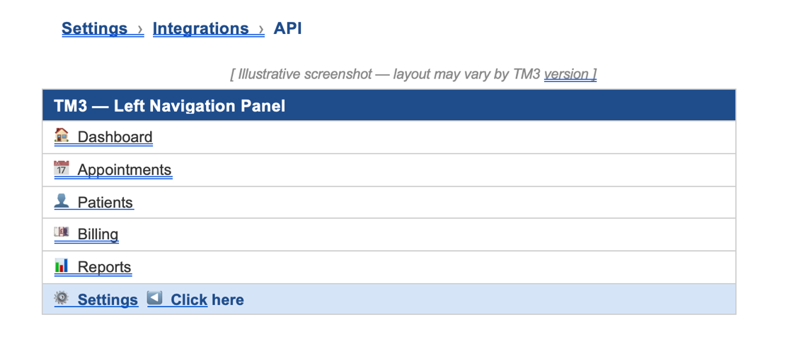
- Navigate to settings > Integrations > API

- Generate a new API token and copy the token
- Paste the token into the TM3 API Token section of the DFI portal

B. Set up eligibility filtering (TM3)
Step 1 — Navigate to Clinical Templates
Log in to TM3 and go to:

Settings › Clinical › Templates

You will see a list of existing Clinical Note templates. Either select an existing template to edit (such as your standard intake or assessment template), or click Add New Template to create a dedicated template for DFI enrolment.

[ Illustrative screenshot — layout may vary by TM3 version ]
TM3 — Settings > Clinical > Templates
Clinical Templates
Initial Consultation | Active | Last edited: 01 Mar 2025
Follow-up Appointment | Active | Last edited: 14 Jan 2025
Discharge Note | Active | Last edited: 05 Feb 2025
+ Add New Template

Step 2 — Open the Template Editor
Click on the template name to open it in the Template Editor. The editor displays a canvas area on the right where the template fields are arranged, and a Field Types panel on the left-hand side containing the available field types you can add.

[ Illustrative screenshot — layout may vary by TM3 version ]
TM3 — Template Editor (Initial Consultation)
Template Editor: Initial Consultation
← Field Types Panel | Text | Yes/No | Options | Number | Date | Slider | Signature ...
Canvas (existing fields) | Patient Name | Date of Birth | Presenting Complaint | ...
Drag a field type from the left panel onto the canvas to add it

Step 3 — Add the Yes/No Field
In the Field Types panel on the left, locate the Yes/No field type. Click and drag it onto the template canvas, positioning it where you would like the enrolment question to appear — typically at the end of the template, under a section heading such as "Platform Enrolment" or "Integrations".

ℹ | TM3's template editor uses a drag-and-drop interface. You can reposition any field after dropping it by dragging it to a new location on the canvas.

[ Illustrative screenshot — layout may vary by TM3 version ]
TM3 — Yes/No Field Added to Canvas
Template Canvas — dragging Yes/No field into position
Presenting Complaint | [Text field]
Treatment Plan | [Text field]
────── Platform Enrolment ──────
▶ Yes/No field dropped here | [ Configure in left panel → ]

Step 4 — Configure the Field Properties
With the Yes/No field selected on the canvas, its properties will appear in the left-hand panel. Configure them as follows:

Property | Setting
Name | Enrol in DFI? (this is the label displayed to the practitioner)
Required | Off (leave unchecked — enrolment should be a deliberate opt-in)
Default Value | Off / No (do not default to Yes — enrolment must be explicit)
Key Question | On (recommended — enables this field to appear in advanced reporting)

[ Illustrative screenshot — layout may vary by TM3 version ]
TM3 — Yes/No Field Properties Panel
Field Properties: Yes/No
Name | Enrol in DFI?
Required | ○ Off ● (toggle)
Default Value | ○ Off (No by default)
Key Question | ● On

⚠ | Do not enable "Default Value" to Yes. If the field defaults to Yes, patients could be inadvertently enrolled in the DFI platform without a deliberate practitioner decision.
Step 5 — Save the Template
Once the field is configured, click the Save button (usually in the top right of the Template Editor). The "Enrol in DFI?" field will now appear in the clinical note whenever this template is used for a patient.

ℹ | Changes to a template do not retroactively affect previously completed notes — they only apply to new notes created after saving.

8.3 How Practitioners Use the Field
Once the template is saved, practitioners will see the "Enrol in DFI?" question when completing a clinical note using that template. The workflow is straightforward:

- Practitioner opens or creates a clinical note for the patient using the relevant template.
- At the "Enrol in DFI?" field, they toggle it to Yes if the patient should be enrolled.
- The note is saved. The value is now stored against that patient's clinical case in TM3.
- The DFI integration reads this field via the TM3 API and ingests the patient into the DFI platform.

[ Illustrative screenshot — layout may vary by TM3 version ]
TM3 — Clinical Note with 'Enrol in DFI?' Field
Clinical Note: Initial Consultation — Jane Smith
Presenting Complaint | Lower back pain, 3 weeks duration
Treatment Plan | Physio 2x/week for 6 weeks
─── Platform Enrolment ───
Enrol in DFI? | ✅ Yes ← practitioner toggles this on
Save Note

8.4 How the DFI Integration Uses This Field
The DFI platform integration queries the TM3 API and filters patients based on the value of the "Enrol in DFI?" field. Only patients where this field has been set to Yes will be ingested. Patients where the field is absent or set to No will be ignored.


To link with PPS
PPS is available in three distinct versions, each with different deployment models. The DFI integration is only compatible with the two cloud-based versions:

Version | Deployment | DFI Compatible?
PPS Express | Web-based (browser, any device) | ✅ Yes — fully supported
PPS Online (Hosted) | Cloud-hosted, accessed via Microsoft Remote Desktop | ✅ Yes — fully supported
PPS Offline (Local) | Locally installed on a PC/laptop, no internet required | ⛔ Not supported

A. Create your API Key (PPS)
- Log in to PPS as an Administrator
- Open system settings

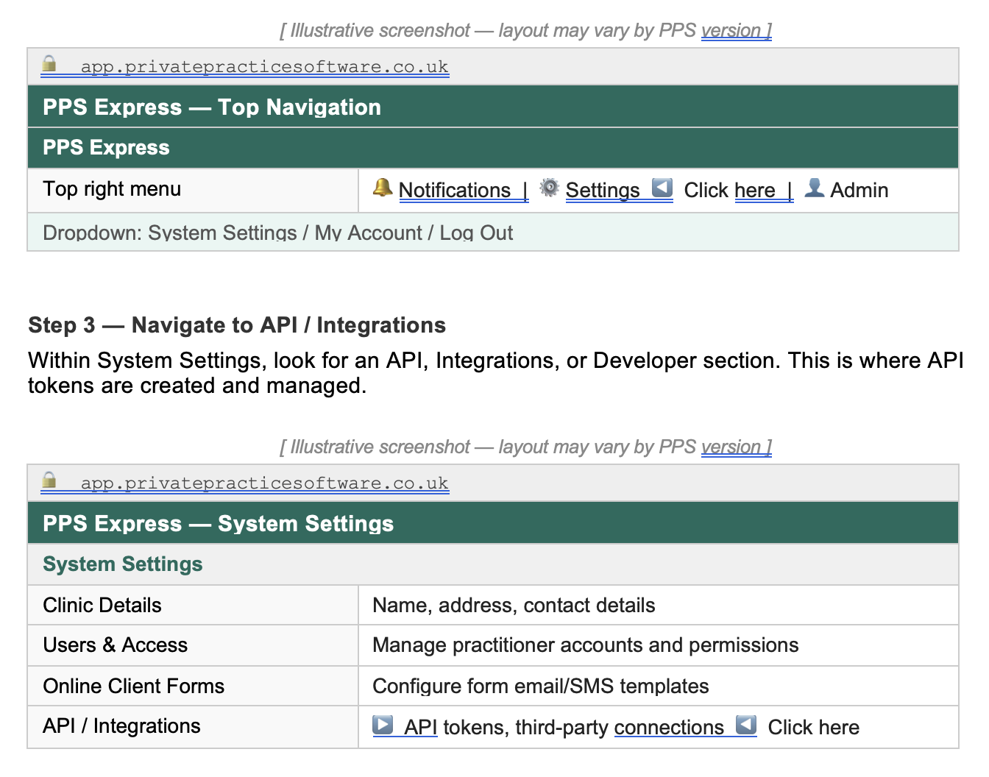

- Generate a new API token and copy the value
- Paste the token into the PPS API Token section of the DFI portal

B. Set up eligibility filtering (PPS)

PPS Online (Hosted) also supports Custom Client Fields — additional fields that appear directly on the client's main details screen (the Profile section), rather than inside a consultation form. This option is not available in PPS Express.

To configure a Custom Client Field, navigate to:
Tools › Options › General System Options › Custom Client Fields

Add a new field with the following settings:

Setting | Value
Field Label | Enrol in DFI?
Field Type | Tick Box / Boolean (Yes/No)
Visible on Client Log | Optional — tick if you want it visible in the client overview
Mandatory | No — leave unchecked
Visible on Minimal Details | Optional

ℹ | Custom Client Fields appear in the Profile section of the Client Details screen. This means the "Enrol in DFI?" flag can be set at any time, not just during a consultation. However, because this option is not available in PPS Express, the Custom Form approach (Option A) is preferred for consistency.

[ Illustrative screenshot — layout may vary by PPS version ]
🔒 Remote Desktop Connection
PPS Hosted — Client Details: Profile Section
Client Details — Profile Tab
Source of Introduction | GP Referral
Occupation | Teacher
─── Custom Client Fields ───
Enrol in DFI? | ☑ (tick box — practitioner checks this)
Save Client Details

6.4 How the DFI Integration Uses This Field
The DFI integration queries the PPS API and reads the value of the "Enrol in DFI?" field on each client. Only clients where this field is checked (Yes) will be ingested.

