AUTOMATE Project plays prominent role in the Tropical Institute for Community Health and Development (TICH) Annual Scientific Conference 2026, Kisumu, Kenya
Plenary session on 11th September 2026: Digital Transformation and Innovation for Health and Development for Measurable Change towards the 2030 Goals
As the world moves closer to the Health for All (HFA) 2028 milestone, the 50th anniversary of the Alma-Ata Declaration and the Sustainable Development Goals 2030 deadline, there is a need for more practical, evidence-based, locally generated solutions. In this context, the 18th TICH Annual Scientific Conference (TASC) brought together Governments, Training Institutions, Faith-Based Organisations, the private sector, NGOs and development partners to reflect on and showcase innovative, community-led solutions and their potential to accelerate progress towards the 2030 goals. The Conference provided an important platform for stakeholders to take stock of progress, share evidence and experiences, identify practical gaps, and define transformative actions that can be implemented using the resources, knowledge and innovations already available within communities and institutions.
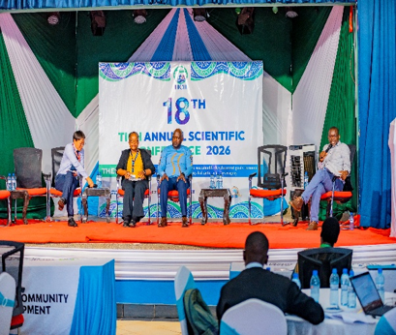
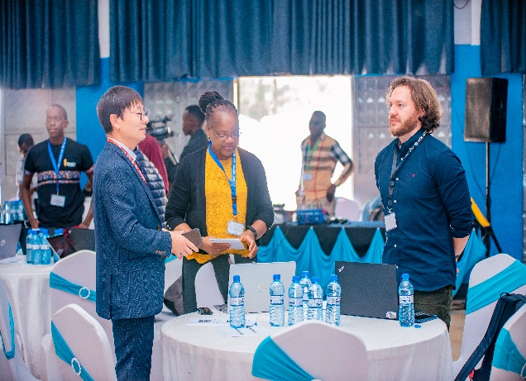

Among the total of six subthemes of the conference, one subtheme, “Digital Transformation and Innovation for Health and Development for Measurable Change towards the 2030 Goals” was specifically dedicated to the AUTOMATE project. The objectives of the project are to establish current capacity to use data and evidence for healthcare decisions, using COVID-19 and maternal, newborn and child health (MNCH) as illustrations; develop intelligent data analytics and visualisation tools to facilitate data access, interpretation and use; and assess the feasibility of digitalising healthcare data for timely MNCH decisions. Keynote speeches were delivered by two members of the AUTOMATE team, Professor Monica Magadi (Keele University), and Professor Yongqiang Cheng (University of Sunderland). These speeches focused on the feasibility and effectiveness of digital interventions to harness routinely collected health data for healthcare decision making and the development of a Maternal Analytics System to transform routine maternal health data into trusted analytical information for evidence-based healthcare management and decision-making. The keynote presentations highlighted that while digitalisation can support timely decision-making, critical factors affecting implementation and use of data need to be addressed early.
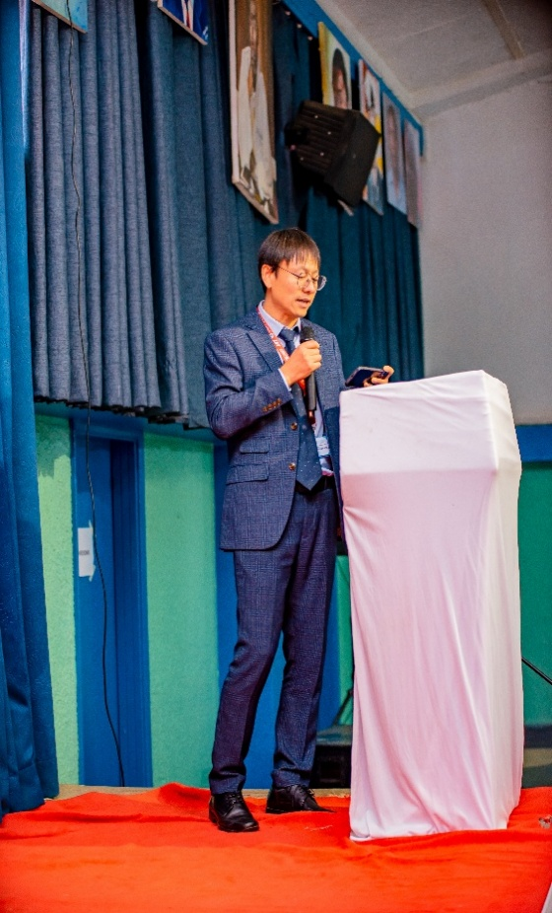
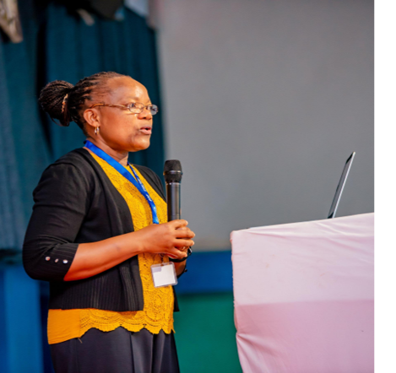

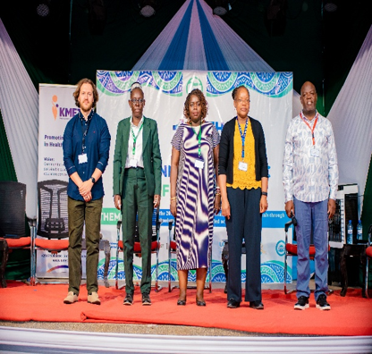

Keynote sessions
Paper presentations

The paper presentations session showcased evidence from illustrative analysis and mixed methods research on assessing the capacity to digitise health facility data, analyse and use for decision-making.

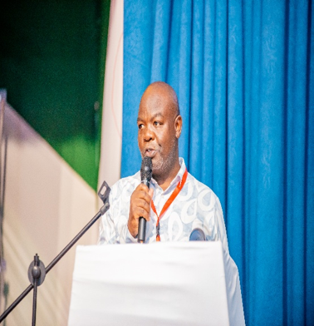


Paper presentations

Presentations were followed by round table discussions. These discussions addressed the need to digitise routinely collected data, especially organic data that can be used to plan interventions as well as the potential for this digital health data to be used to improve healthcare. In Kenya, many systems are currently manual or hybrid, however, there is a great opportunity to improve from manual to fully digitised data systems. The AUTOMATE project is building the capacities of Health records information officers to digitise analyze and generate evidence for timely decision making. AI has the potential to be used as a supportive tool by providing predictive analytics.
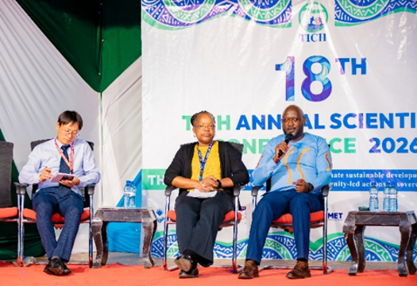
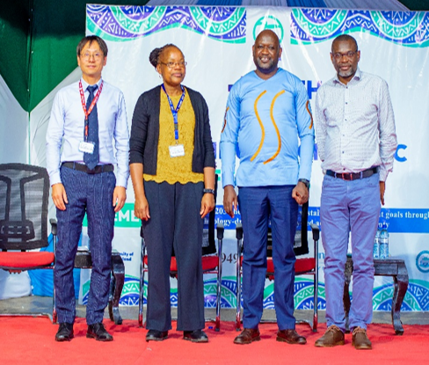
Round Table panelists

Questions from the audience around data security were also fielded during the round table discussions. These concluded that personal data can remain secure when digitisation is supported by strong data protection frameworks, ethical oversight, and robust governance mechanisms; data access and use should comply with approved ethical standards and national regulations; and working closely with government institutions helps to ensure privacy and security. In Kenya, robust data governance policies provide safeguards for responsible data management and use.
Furthermore, to safeguard privacy in digital health systems, unique identifiers can be used instead of personal information to enable anonymous data management. However, digitisation may pose risks such as loss of privacy, misinformation, and blurred distinctions between real and virtual environments. Strong authentication mechanisms, clear data security guidelines, and strict adherence to patient confidentiality are essential to ensure the safe and ethical use of digital health data.

Capacity building sessions on Better Decision-Making Using Routine Health Data.
Routine health systems generate large amounts of data every day, but collecting and reporting this data does not automatically translate into using it for decision-making.
In August and September 2026, the AUTOMATE Project team trained 25 data officers and managers in Siaya and Kisumu Counties on ‘Applied Data Science for Integrated Decision Support’ prior to and during TASC. The aim of the training was to move data teams from reporting on what has happened, to using routine health data to anticipate what may happen next and support preparedness at the health facility, sub-county, and county levels.
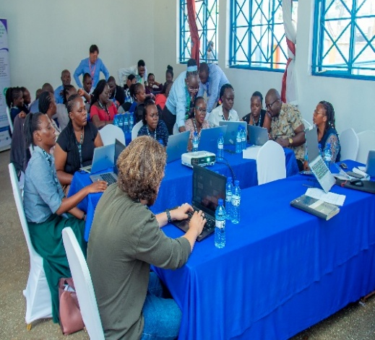
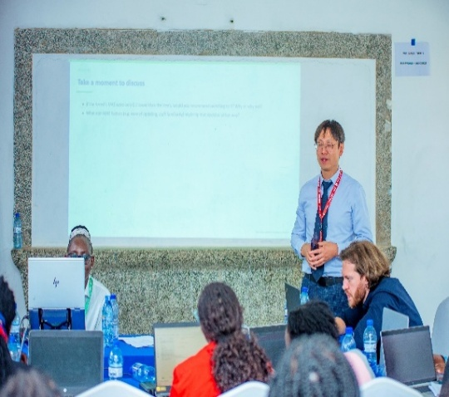
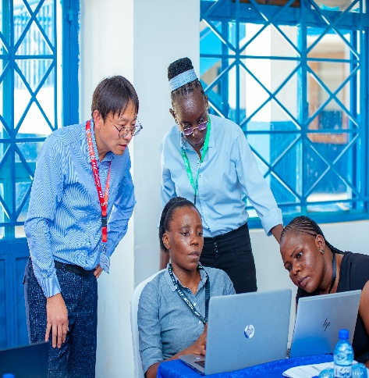

Capacity building sessions

Participants worked in Python using ANC and maternity datasets and learned how to prepare and check data, integrate multiple datasets, formulate a prediction problem, build and evaluate predictive models, and translate results, eventually creating decision-support information for management action.
Moving forward, the AUTOMATE project team will continue engaging the data teams for further capacity building on advanced visualizations being piloted in November 2026 using tools developed during the project.

Project partners and funding (https://www.nihr.ac.uk/research-funding/global-health)







Funding Acknowledgement:
This research was funded by the NIHR (NIHR157653) using UK international development funding from the UK Government to support global health research. The views expressed in this publication are those of the author(s) and not necessarily those of the NIHR or the UK Government.

