

Connecting your Practice Management System (PMS) to the Data for Impact (DfI) Platform
Overview
What this integration does
This guide explains how to connect your Practice Management System (PMS) to the Data for Impact (DfI) platform using an API key.
Once connected, eligible patient details automatically transfer from your PMS into DfI, removing the need for manual enrolment directly on to the DfI platform. When a patient is added to your PMS, their details flow securely into DfI and patient surveys are sent automatically at the appropriate time.
You can then view:
- Individual patient survey responses (via the DfI platform)
- Aggregated clinic-level outcomes and benchmarking (via the DfI dashboard)
This integration is designed to reduce administrative burden and fit into routine clinical workflows.

One-off setup
You only need to complete this process once. After the API connection is set up, eligible patient details will continue to transfer automatically from your PMS into DfI.

Data protection and GDPR
To reassure you and your patients:
- No clinical notes, treatment records, or free-text data are shared
- Only the minimum information required to enrol patients into DfI and send surveys is transferred (for example: name, contact details, D.O.B and appointment details)
- All data are handled in line with GDPR requirements and the DfI governance framework, hosted at Keele University

Important: eligibility filtering (why this matters)
Practice Management Systems may also include patients who should not be enrolled into DfI, for example:
- Non-physiotherapy appointments in multidisciplinary clinics
- Non-MSK or non-eligible services
For this reason, part of the setup involves adding a simple eligibility filter in your PMS. This ensures that only appropriate patients are sent to DfI, protecting data quality and avoiding inappropriate survey delivery.
As part of this process, we will guide you through:
- How to set up the API link
- Where to add an eligibility filter in your PMS (if applicable i.e. if you have patients who are not eligible for enrolment to the DfI)
- How to label or flag eligible patients
- How to test the connection safely before going live

What happens after setup
Once connected and tested:
- Eligible patients are enrolled automatically onto the DfI platform
- Patient surveys are sent without any additional administrative work
- Your clinic’s data contribute to the national MSK evidence base
- You gain access to meaningful benchmarking and reporting via the DfI dashboard

How to set up the API connection and eligibility filtering
Connecting your PMS to the DfI platform involves two simple steps, regardless of which PMS you use:
- Create an API key
This allows your PMS and the DfI platform to communicate securely.
- Set up eligibility filtering
This controls which patients are sent to DfI, ensuring only appropriate physiotherapy patients are enrolled.
You only need to complete these steps once. Once the connection is live, the system will continue to work automatically in the background.
We have established API integrations with the following Practice Management System (PMS) providers, with plans to expand these integrations further in the future:
- Nookal (page 4)
- Cliniko (page 6)
- TM3 (coming soon)
- PPS (coming soon)
Please see the relevant pages and then information on how to test the API connection (page 9).


To link with Nookal
A. Create your API Key & Secret (Nookal)
- Log in to Nookal using an Owner or Admin account
- Go to Setup
- Select Integrations
- Open API Keys
- Click New API Key
- Name it:
“MSK Data for Impact”
- Nookal will generate:
  - API Key
- Copy both values
- Paste them into the DfI PMS Integration form (see Account page; connect to PMS)
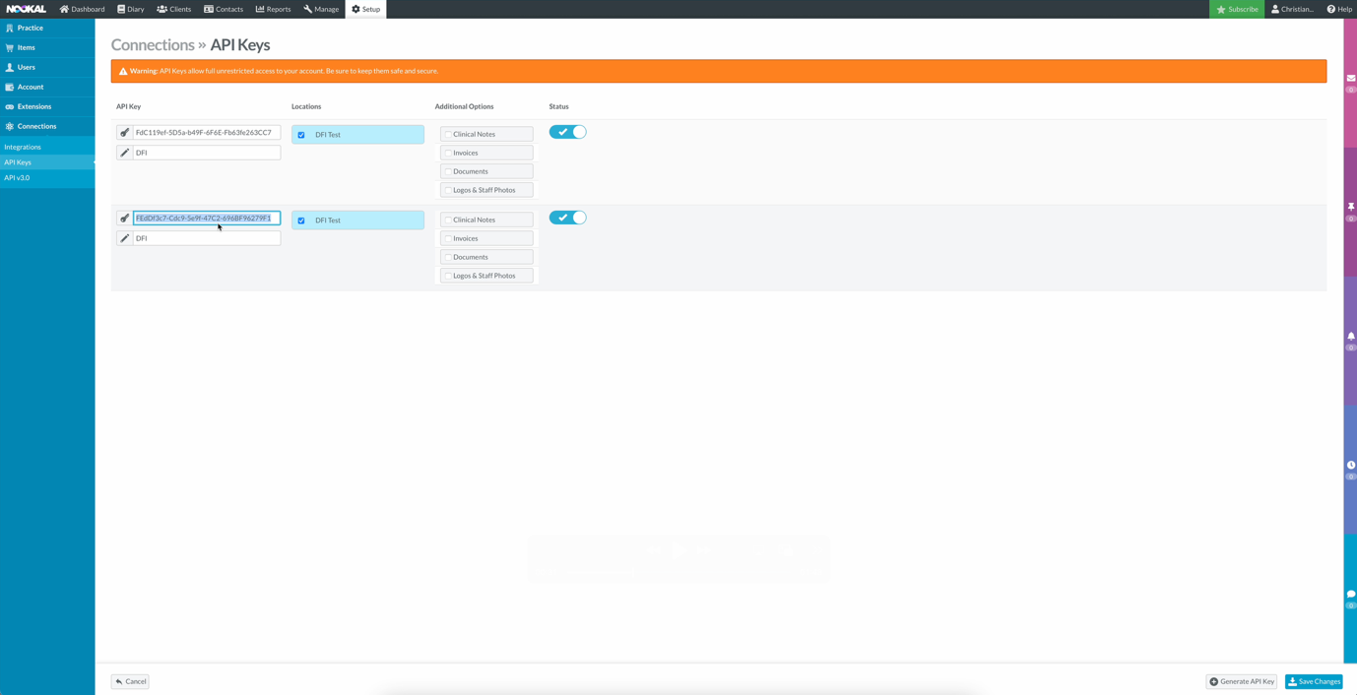
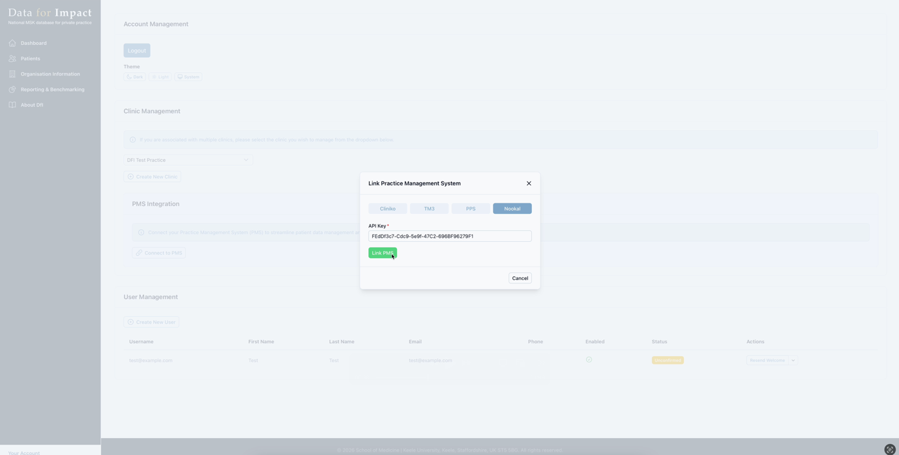

B. Set up eligibility filtering (Nookal)
In order to filter patients that whose details you don’t want to be sent to DFI, follow the steps below.
- Go to Extras on the practice settings.
- Create an extra field with the type as “Checkbox” and the name “Enrol in DFI?”.
- Add one option with the value “Yes”
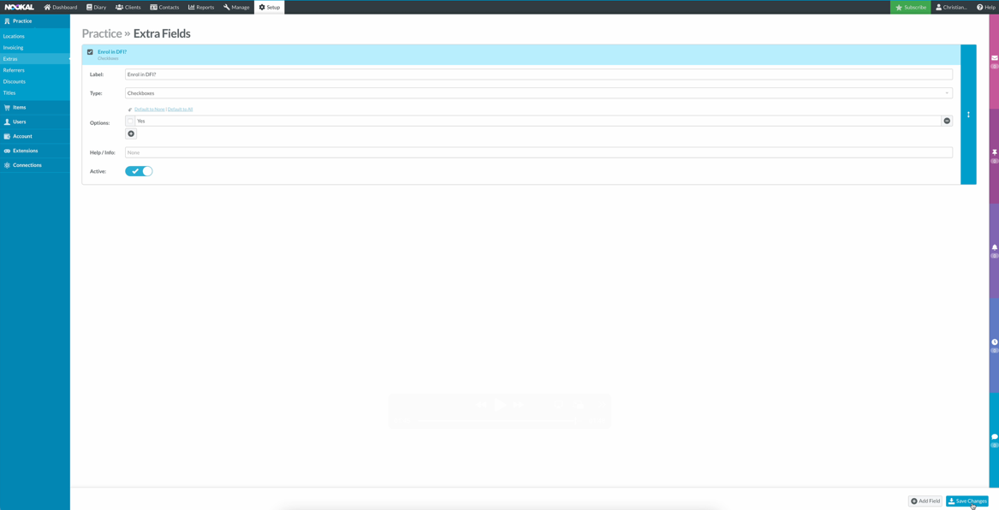
- When a patient is enrolled into your PMS, you will now see a checkbox, which will need to be checked in order for patient and appointment data to be sent to DFI.


To link with Clinko
A. Create your API Key (Cliniko)
- Log in to Cliniko as an Administrator
- Go to Settings
- Select API
- Click Add API Key
- Name it:
“Data for Impact (DfI)”
- Copy the generated API key
- Paste into the DfI PMS Integration form (see Account page; connect to PMS). Once pasted, click “Link PMS” – you will then be asked which Practice you would like to link from your PMS.
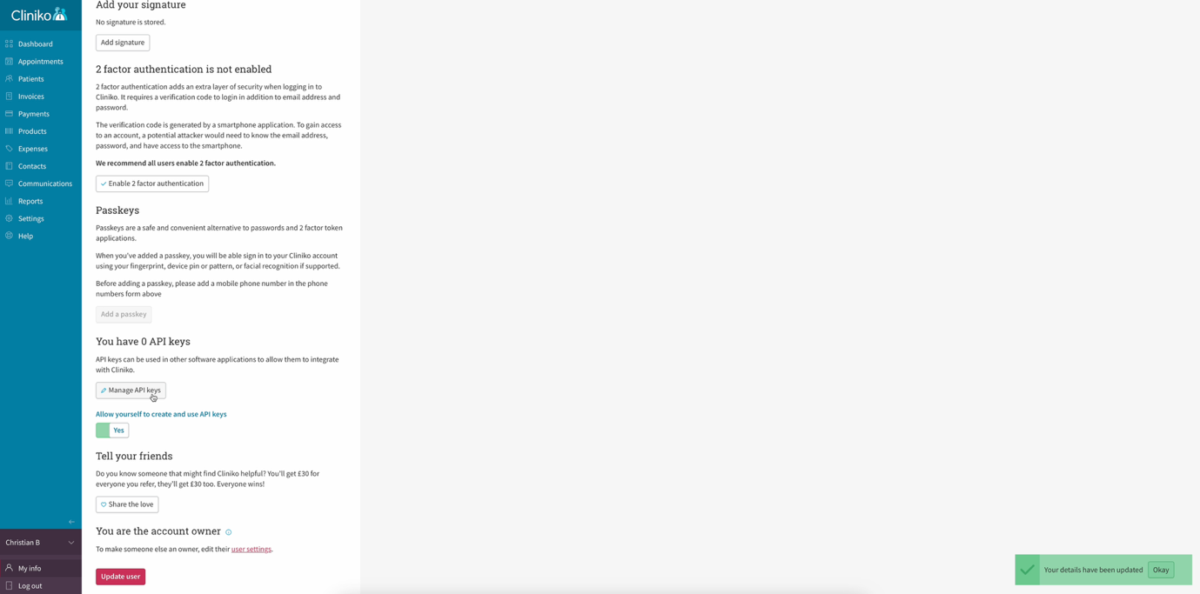
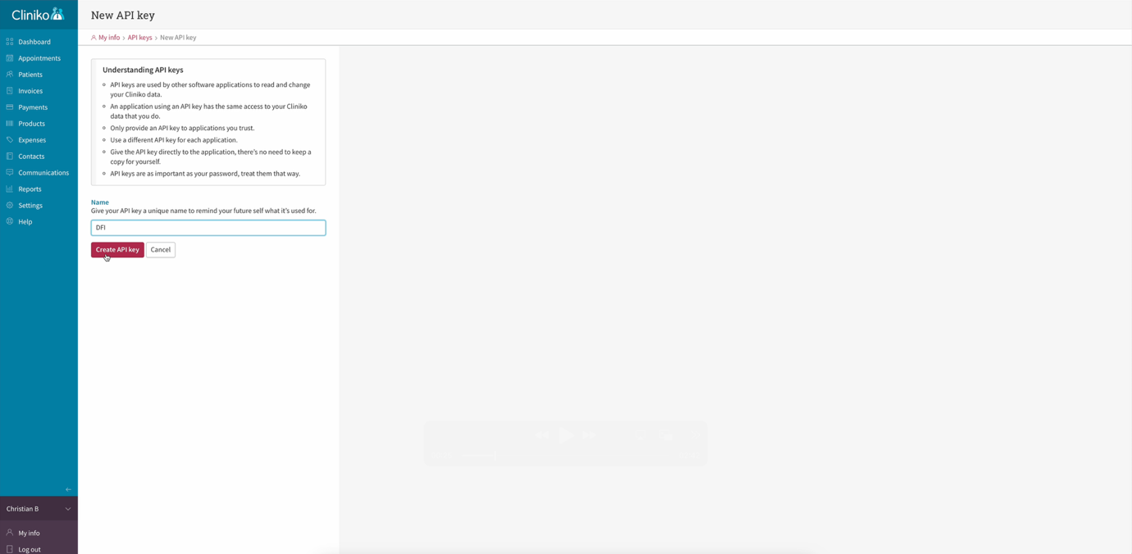
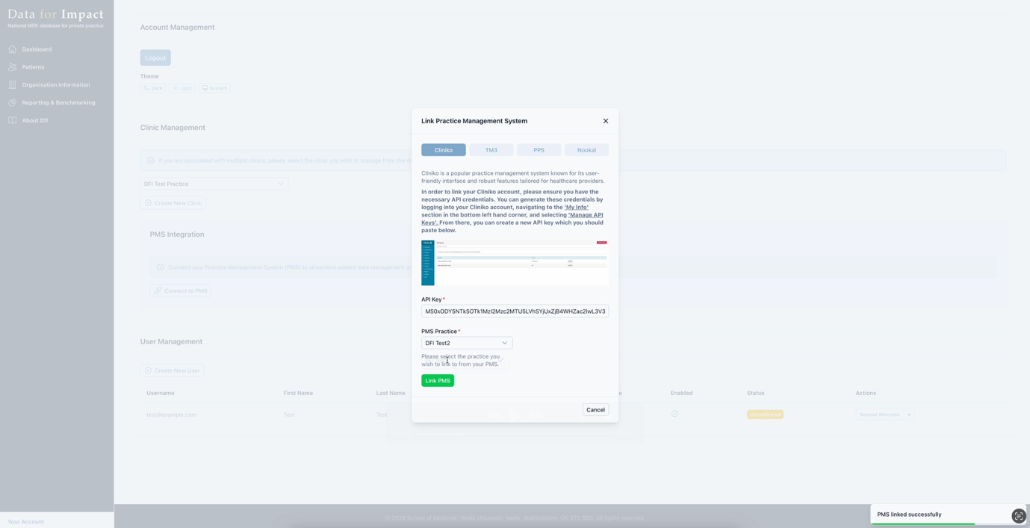
B. Set up eligibility filtering (Cliniko)
In order to filter patients that whose details you don’t want to be sent to DFI, follow the steps below.
- Go to “Settings” and click “Custom Patient Fields”
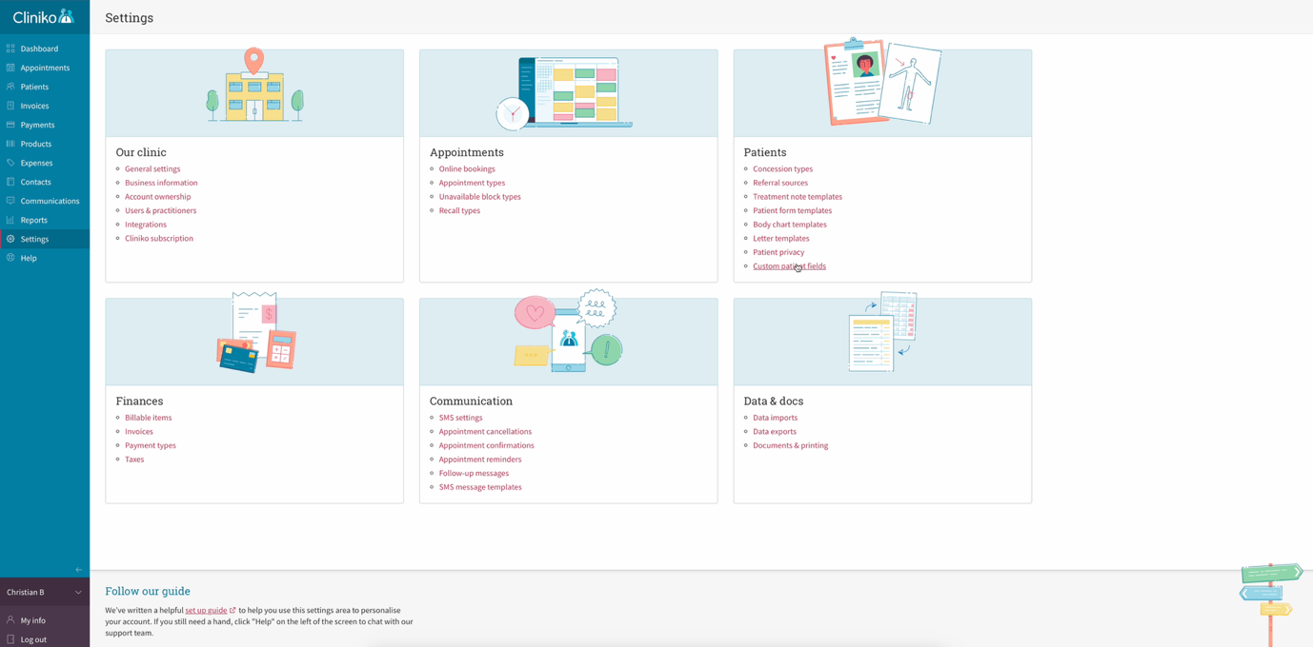

- Create a new section called “DFI” and a new checkbox field called “Enrol in DFI”, with one option labelled “Yes”. Once complete, save the field.
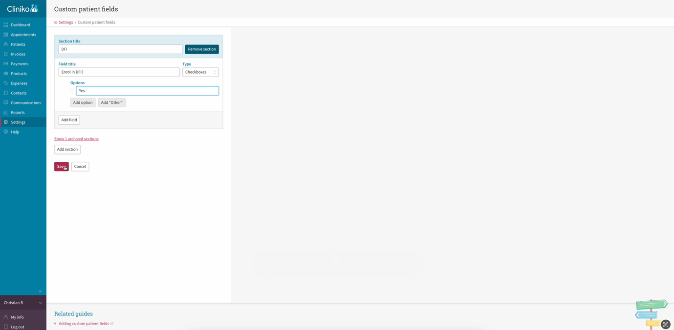

- When enrolling new patients in your PMS, you will now see a checkbox called “Enrol in DFI?”, which needs to be checked in order for DFI to receive patient and appointment data.

Testing before going live (all PMS)
Before fully enabling:
- Create a test patient
- Book an eligible physiotherapy appointment
- Confirm:
  - patient appears in DfI
  - surveys are sent correctly
- Adjust filters if needed
We recommend testing with 1–2 patients before full rollout.

Need help?
If you would like:
- Further information then please contact the DfI research team.

